Appendix X

Specifications for the In Depth Assessment of North Pacific humpback whales
Debra Palka, Greg P. Donovan, Kristin M. Privitera-Johnson, André E. Punt, Paul R. Wade

- Basic concepts: Stock and spatial structure
Two breeding stock structure hypotheses are considered. Asia, Hawaii, and Central America (Central_Am) are breeding areas in breeding stock hypotheses B1 and B2. All the whales that breed near Mexico during the winter are treated as a single stock in breeding stock hypothesis B1: including Mainland (MX_ML), the Archipiélago de Revillagigedo (MX_AR) and Baja California (MX_BJ). Whales that winter near Mexico are divided into two breeding stocks in breeding stock hypothesis B2: MX_AR and MX_ML (Table A.1). The whales found near Baja California (MX_BJ) are excluded from the B2 breeding stock hypothesis based on evidence of mixing with MX_AR and MX_ML.
There are two hypotheses regarding how the feeding grounds are combined (F1 and F2; Table A.1). These hypotheses differ in terms of where the Western Gulf of Alaska (WGOA) region is included. The WGOA is combined with the Northern Gulf of Alaska (NGOA) in feeding ground hypothesis F1 to create the Gulf of Alaska (GOA) region (WGOA+NGOA). The WGOA is combined with the eastern Aleutians (EAL) and Bering Sea (BER) to form the EAL+BER+NGOA region in feeding ground hypothesis F2.
Combining the breeding and feeding hypotheses leads to four “cases” (B1-F1, B2-F1, B1-F2, B2-F2). Table A.2 shows the presence-absence matrices for each “case”. These matrices specify the feeding grounds where animals from each breeding stock migrate to during the summer.
Table A.1. Regions and their abbreviations. Descriptions use stratum names from some previous papers as a reference. See Fig. A.1 for the locations of the regions.

Region (Abbreviation) | Description | Option
Breeding Stock
Asia (AS) | The Asian breeding region is the total of the following spatial strata as defined in Fig. A.1: “All Asia” (Philippines and Okinawa), “Japan” (Yellow Sea, Japan Sea, and around Japan), Ogasawara, and the Marianas regions | B1, B2
Hawaii (HI) | Around the Hawaiian Islands | B1, B2
Mainland Mexico (MX_ML) | The main breeding ground is off the mainland from Mazatlán (Sinaloa) to Colima, including Bahía de Banderas (Nayarit/Jalisco) and the Tres Marías Islands and Isla Isabel. | B2
Mexico Offshore Revillagigedo Archipelago (MX_AR) | Revillagigedo Archipelago is a main breeding ground and, to a lesser extent, the Baja California Peninsula and Bahía de Banderas  (Nayarit and Jalisco). | B2
Mexico | MX_ML MX_AR, and MX_BJ combined | B1
Southern Mexico to Central America (Central_Am) | From southern Mexico (Michoacan, Guerrero, Oaxaca and Chiapas) to Central America (Guatemala to Panama). Humpbacks also travel along a migratory corridor through Colima, Bahía de Banderas (Nayarit/Jalisco), and Baja California Sur. | B1, B2
Breeding/Feeding/Migratory Region
Baja California Mexico (MX_BJ) | Waters off the coast of Baja California Sur in the Baja California Peninsula (MX_BJ) is used by the two Mexican breeding regions (MX_ML and MX_AR) and by the Central_Am breeding group to feed and migrate to more northern waters.
Feeding Grounds
Russia and Western Aleutians  (RUS+WAL) | Includes Kamchatka, the Gulf of Anadyr, the Commander Islands,  and the Western Aleutians | F1, F2
Eastern Aleutians and Bering Sea (EAL+BER) | The Eastern Aleutians and Bering Sea | F1
Gulf of Alaska (GOA) = WGOA+NGOA | The Western Gulf of Alaska (WGOA) and the Northern Gulf of  Alaska (NGOA) | F1
Eastern Aleutians, Bering Sea and Western Gulf of Alaska (EAL+BER+WGOA) | The Eastern Aleutians, Bering Sea, and Western Gulf of Alaska | F2
Northern Gulf of Alaska (NGOA) | The Northern Gulf of Alaska | F2
Southeast Alaska to Northern British Columbia (SEA+NBC) | Southeast Alaska and Northern British Columbia | F1, F2
Southern British Columbia and Washington (SBC+WA) | Southern British Columbia and Washington | F1, F2
Oregon and California (OR+CA) | Oregon and California | F1, F2

Table A.2. Presence / absence matrices for the stock and spatial scenarios.
B1-F1 | Feeding ground |  |  |  |  | Breeding stock
RUS + WAL | EAL+BER | GOA | SEA+NBC | SBC+WA | OR+CA
Yes | Yes | - | - | - | - | Asia
Yes | Yes | Yes | Yes | Yes | - | Hawaii
Yes | Yes | Yes | Yes | Yes | Yes | Mexico
- | - | - | - | Yes | Yes | Central America
B1-F2
RUS + WAL | EAL+BER+WGOA | NGOA | SEA+NBC | SBC+WA | OR+CA
Yes | Yes | - | - | - | - | Asia
Yes | Yes | Yes | Yes | Yes | - | Hawaii
Yes | Yes | Yes | Yes | Yes | Yes | Mexico
- | - | - | - | Yes | Yes | Central America
B2-F1
RUS + WAL | EAL+BER | GOA | SEA+NBC | SBC+WA | OR+CA
Yes | Yes | - | - | - | - | Asia
Yes | Yes | Yes | Yes | Yes | - | Hawaii
Yes | Yes | Yes | Yes | Yes | Yes | MX_AR
Yes | Yes | Yes | Yes | Yes | Yes | MX_ML
- | - | - | - | Yes | Yes | Central America
B2-F2
RUS + WAL | EAL+BER+WGOA | NGOA | SEA+NBC | SBC+WA | OR+CA
Yes | Yes | - | - | - | - | Asia
Yes | Yes | Yes | Yes | Yes | - | Hawaii
Yes | Yes | Yes | Yes | Yes | Yes | MX_AR
Yes | Yes | Yes | Yes | Yes | Yes | MX_ML
- | - | - | - | Yes | Yes | Central America

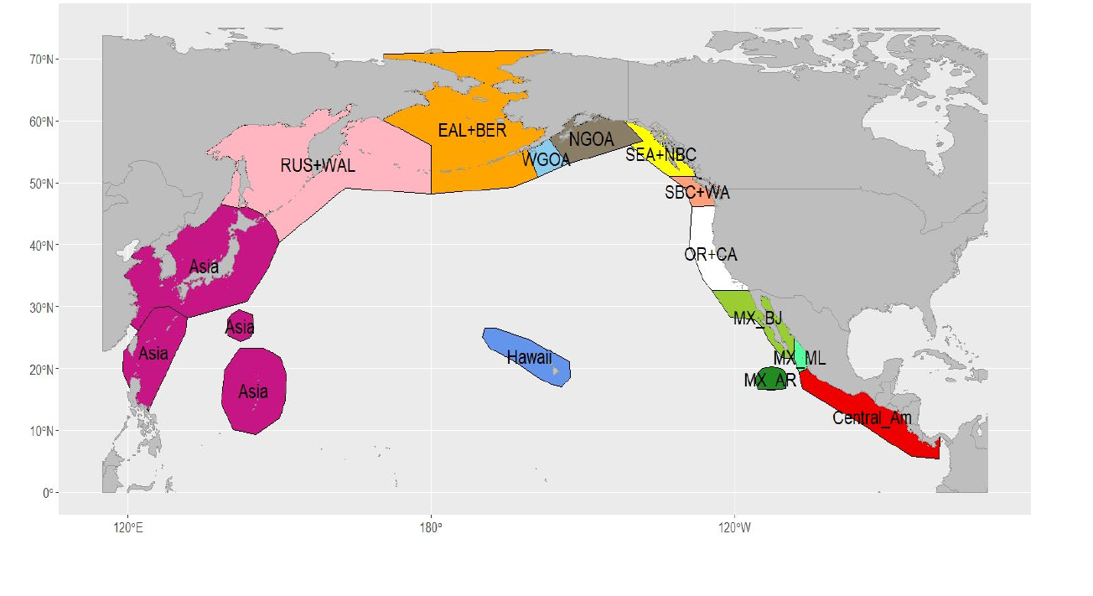
Fig. A.1. Boundaries for the breeding and feeding areas.

- Population dynamics model
B.1 Population dynamics model for the base-case model
The framework for conducting the assessment for the North Pacific humpback whales is based on a sex- and age-aggregated population dynamics model that accounts for multiple breeding stocks. Animals from each breeding stock are found during the summer on some of the feeding grounds (Table A.2). Each breeding stock is modelled as a ‘herd’ so that animals of a given breeding stock that feed in a given feeding ground have fidelity to that feeding ground (although the model includes the ability to account for straying of animals among feeding grounds (see Section B.2), but this does not form part of the assumptions of the base-case model).
The population dynamics are based on the following equation:
$N_{y}^{b,f}=S_{y-1}^{b,f}{\tilde{N}}_{y-1}^{b,f}+f_{y-L+1}^{f}{\left(\frac{S_{C}}{S}\right)\prod_{v=0}^{L+1}{S_{y-v}^{b,f}}\tilde{N}}_{y-L+1}^{b,f}$ (B.1)
where $N_{y}^{b,f}$ is the number, at the start of year y, of breeding stock b animals that feed in feeding ground f, $f_{y}^{f}$is the fecundity for animals on feeding ground f during year y, $S_{y}^{b,f}$ is the survival rate for breeding stock b animals on feeding ground f during year y, L is the age-at-maturity, $S_{C}$ is calf survival in the absence of environmental perturbations , S is the base-case value for survival across all breeding stocks, feeding grounds, and years, ${\tilde{N}}_{y}^{b,f}$ is the number of breeding stock b animals in feeding ground f after all of the removals during year y:
${\tilde{N}}_{y}^{b,f}={\tilde{\tilde{N}}}_{y}^{b,f}\left({\tilde{\tilde{N}}}_{y}^{f}-C_{y}^{f}\right)/{\tilde{\tilde{N}}}_{y}^{f}$ (B.2)
$C_{y}^{f}$ is the number of removals due to direct removals and bycatches / ship strikes from feeding ground f during year y (see Adjunct 1), ${\tilde{\tilde{N}}}_{y}^{b,f}$ is the number of breeding stock b animals in feeding ground f after the breeding ground removals during year y (${\tilde{\tilde{N}}}_{y}^{f}=\sum_{b}{{\tilde{\tilde{N}}}_{y}^{b,f}}$):
${\tilde{\tilde{N}}}_{y}^{b,f}=N_{y}^{b,f}\left(N_{y}^{b}-C_{y}^{b}\right)/N_{y}^{b}$ (B.3)
$C_{y}^{b}$ is the number of removals due to direct removals and bycatches / ship strikes from breeding stock b during year y (see Adjunct 1), $N_{y}^{b}$ is the total number of breeding stock b animals at the start of year y ($N_{y}^{b}=\sum_{b}{N_{y}^{b,f}}$).
Fecundity is assumed to be a function of the density on each feeding ground, i.e.:
$f_{y}^{f}=f_{0}-(f_{max}-f_{0})(1-\frac{N_{y}^{f}}{K^{f}})$) (B.4)
where f₀ is fecundity at carrying capacity, f_{max} is fecundity in the limit of zero population size, and K^{f} is the carrying capacity for feeding ground f. The value f₀ is determined from Eqn B.1 at unfished equilibrium (i.e. 1-S where), and f_{max} is determined from the Lokta equation given a value for the maximum rate of increase r_{max}, i.e.:
$f_{max}=({\left(1+r_{max}\right)}^{L+1}-S{\left(1+r_{max}\right)}^{L})/$( $S^{L}S_{C})$ (B.5)
Annual survival for animals in feeding ground f is given by:
$S_{y}^{b,f}=\frac{1}{1+exp\left(+{}_{y}^{f}{}_{S}\right)}$ (B.6a)
$=ln⁡\left(1/S-1\right)$ ` (B.6b)
where ${}_{y}^{f}$ is the deviation in survival for feeding ground f during year y, and ${}_{S}$ determines the inter-annual variability in S.
B.2 Specifications for sensitivity tests
Most of the sensitivity tests involve changes to the values of the parameters of the population dynamics or observation models (see Section D.2). An exception to this is how modelling of straying among feeding grounds within breeding stocks is implemented. The number of animals of breeding stock b on feeding group f straying to feeding ground f’=f-1 (where the order of feeding grounds matches their geographic order), ${\tilde{\tilde{N}}}_{y}^{,Stray,b,f,f'},$ depends on the relative depletion of feeding grounds f and f-1. Straying is assumed to occur after any breeding ground catches but before any feeding ground catches, i.e.:
${\tilde{\tilde{N}}}_{y}^{,Stray,b,f,f'}={\tilde{\tilde{N}}}_{y}^{b,f}\left(\frac{(R_{y}^{b,f,f^{'}}-1)}{1+exp\left(-100\left(R_{y}^{b,f,f^{'}}-1\right)\right)}\frac{1}{1+exp\left(100\left(R_{y}^{b,f,f^{'}}-2\right)\right)}+\frac{1}{1+exp\left(-100\left(R_{y}^{b,f,f^{'}}-2\right)\right)}\right)$ (B.7)
where β is straying rate (0 for the base-case model), and $R_{y}^{b,f,f^{'}}$ is the relative depletion ratio:
$R_{y}^{b,f,f^{'}}=\left({\tilde{\tilde{N}}}_{y}^{b,f}/K^{f}\right)/\left({\tilde{\tilde{N}}}_{y}^{b,f'}/K^{f'}\right)$ (B.8)
Two alternative ways to model calf production are considered. Eqn B.9a assumes that calves select feeding grounds in the same proportions as at carrying capacity while Eqn B.9b assumes that calves select feeding grounds in proportion to abundance by feeding ground at carrying capacity as well as the number of breeding stock animals by herd:
$N_{y}^{b,f}=S_{y-1}^{b,f}{\tilde{N}}_{y-1}^{b,f}+f_{y-L+1}^{f}{\tilde{N}}_{y-L+1}^{b}{}^{b,f}$ (B.9a)
$N_{y}^{b,f}=S_{y-1}^{b,f}{\tilde{N}}_{y-1}^{b,f}+f_{y-L+1}^{f}0.5({\tilde{N}}_{y-L+1}^{b}{}^{b,f}+{\tilde{N}}_{y-L+1}^{b,f})$ (B.9b)
where ${}^{b,f}$is the proportion of animals from breeding stock b that recruit to feeding ground f.
- Model parametrization and fitting
C.1 Model parameterization
The estimable parameters of the population dynamics model (Table C.1) are the maximum rate of growth (r_{max}), the carrying capacity of each breeding stock (K^{b}, estimated in log-space), the relative depletion of each breeding stock at the start of modelled period (1970, estimated in log-space), the parameters that determine how much of each breeding stock migrates to each feeding ground at carrying capacity (i.e., the parameters of the “mixing matrix”, δ - the entries of the matrix δ are zero for breeding stock-feeding ground combinations for which the data (or a priori assumptions) indicate that no animals of a breeding stock occur in that feeding ground - Table A.2), and the parameters that determine how much survival deviates from S (${}_{y}^{f}$ ), Note that the number of estimated mixing matrix entries for each breeding stock is one less than the number of feeding grounds it is assumed to feed in given the constraint $\sum_{f}{{}_{}^{b,f}}=1$. Some of the sampling coefficients of variation appear to be very low so it is possible to estimate an “additional variance” parameter for the associated time-series of abundance estimates and indices. The estimable parameters of the observation model are therefore the additional variance parameters for three of the time-series of abundance estimates (the estimates of absolute abundance for the SBC+WA and OR+CA feeding grounds and the relative index of abundance for the GOA feeding ground).

Table C.1 List of parameters. The number in parenthesis is the number of estimated parameters for the base-case application of the model.

Parameter | Treatment
r_{max,} the maximum rate of growth | Estimated (1)
Ln K^{b}, carrying capacity of each breeding stock | Estimated (4)
$N_{1970}^{b}/K^{b}$, relative depletion of each breeding stock at the start of modelled period | Estimated (one for each breeding stock) (4)
${}_{}^{b,f}$, the parameters of the “mixing matrix” | Estimated (how many depends on how many feeding grounds there are for each breeding stock) (11)
τ, “Additional variance” parameters | Estimated for the SBC+WA, OR+CA relative abundance indices and the GOA absolute abundance estimates (3)
${}_{y}^{f},$the parameters that determine how much survival deviates from S | Estimated - one parameter for each year for the feeding grounds for which there are survival deviates (96)
S_{C}, Calf survival rate for years with no survival deviates | Pre-specified – 0.8
S, 1+ survival rate for years with no survival deviates | Pre-specified - 0.96
L, Age-at-maturity | Pre-specified – 8 years
${}_{S}^{}$, extent of variation in the survival deviations | Pre-specified - 6
C.2 Objective function
The objective function minimized to find the estimates of the parameters of the model involves four types of data (in addition to a penalty of how much survival can vary from its base-case value and small penalties to assist with convergence): (a) estimates of absolute abundance, (b) indices of relative abundance, (c) estimates of the proportion of the animals on a feeding ground that come from each breeding ground, and (d) estimates of the proportion of a breeding stock that migrates to each feeding ground.
C.2.1 Likelihood components
The contribution of the estimates of absolute abundance for feeding ground f (Section A of Adjunct 2) to the negative of the log-likelihood function is:
$-lnL=\sum_{y}{\left(ln{\tilde{}}_{y}+{\frac{1}{2{\tilde{}}_{y}^{2}}\left(lnN_{y}^{Obs,f}-lnN_{y}^{f}\right)}^{2}\right)}$ (C.1)
where $N_{y}^{Obs,f}$ is the abundance estimate for feeding ground y during year y, ${\tilde{}}_{y}$ is the assumed standard error of the logarithm of $N_{y}^{Obs,f}$ (${\tilde{}}_{y}= \sqrt{{CV}_{y}^{2}+{}^{2}}$ where ${CV}_{y}^{}$ is the CV of $N_{y}^{Obs,f}$ and ${}_{}^{2}$ is the additional variance), and $N_{y}^{f}=\sum_{b}{N_{y}^{b,f}}$. Eqn C.1 is extended naturally for the estimates of absolute abundance by breeding ground and the estimates of abundance for entire North Pacific. The contribution of the estimates of relative abundance for feeding ground f (Section B of Adjunct 2) to the negative log-likelihood is:
$-lnL=\sum_{y}{\left(ln{\tilde{}}_{y}+{\frac{1}{2{\tilde{}}_{y}^{2}}\left(lnN_{y}^{Obs,f}-ln{(qN}_{y}^{f})\right)}^{2}\right)}$ (C.2)
where q is the constant of proportionality (survey bias). The values for the q parameters are obtained analytically given Eqn C.2.
The contribution of the mixing data (Section C of Adjunct 2) depends on whether these data are the proportion of each breeding stock that migrates to each feeding ground or the proportion that each breeding stock makes up of each feeding ground. These data are assumed to be multinomial. For the case of data by breeding stock on the split to feeding ground:
$-lnL=\sum_{b}{{}_{y*}^{b}\sum_{f}{{}_{y*}^{Obs,b,f}ln⁡({}_{y*}^{,b,f}/{}_{y*}^{Obs,b,f})}}$ (C.3)
where ${}_{y*}^{Obs,b,f}$ is the observed proportion of breeding stock b animals that migrate to feeding ground f during year y*, ${}_{y*}^{Obs,b,f}$ is the model-predicted proportion of breeding stock b animals that migrate to feeding ground f during year y*, i.e.:
${}_{y}^{b,f}=N_{y}^{b,f}/N_{y}^{b}$ (C.4)
${}_{y*}^{b}$ is the effective sample size for breeding stock b. The value of ${}_{y*}^{b}$ is set based on the following “overdispersion” estimator:
${}_{y*}^{b}=\frac{\sum_{f}{{}_{y*}^{Obs,b,f}(1-{}_{y*}^{Obs,b,f})}}{\sum_{f}{{\left({SD}^{b,f}\right)}^{2}}}$ (C.5)
where ${\left({SD}^{b,f}\right)}^{2}$ is the variance of ${}_{y*}^{Obs,b,f}$. The value of ${}_{y*}^{b}$ is constrained not to exceed a threshold value (base-case uses a value of 100).
C.2.2 Survival penalty
The contribution of the deviations in survival about expected survival is given by:
$-lnL=\sum_{f}{\sum_{y}{\left(ln{}_{S}+\frac{{\left({}_{y}^{f}\right)}^{2}}{2{}_{S}^{2}}\right)}}$ (C.6)
where ${}_{S}^{}$ is the (assumed) extent of variation in the survival deviations.
C.3 Quantifying uncertainty
The measure of uncertainty for the bulk of the analyses are 95% confidence intervals based on calculating standard errors for the parameters by inverting the Hessian matrix and applying the Delta method for derived quantities such as the numbers by breeding stock and feeding ground. This approach can lead to unrealistic outcomes for parameters and derived quantities that are bounded. This is most evident for annual survival, which is bounded above by 1 but the upper 95% confidence interval limit for which can exceed 1. An alternative approach for quantifying uncertainty is to apply a bootstrap procedure combined with the percentile method for calculating confidence intervals.
The (parametric) bootstrap procedure of this paper involves generating pseudo data sets by:
- Generating alternative time-series of abundance estimates under the assumption that they are log-normal, with expectations given by the model predictions obtained by fitting the model to the actual data and standard errors of the log set to the CVs for actual abundance estimates (accounting for additional variance for the indices for which this is estimated).
- Generating alternative sets of mixing matrices based on multinomial sampling using the model-predictions of the mixing proportions obtained by fitting the model to the actual data as the expected proportions and rounded values of Ω as the effective sampling sizes.
This bootstrap procedure assumes that the model fit is adequate, i.e. there is no evidence for systematic patterns in the residuals, which is largely correct.

- Specifications of the base-case model and the sensitivity tests
D.1 Base-case specifications
The estimated parameters of the population dynamics model are listed in Table C.1. The base-case value for the natural survival rate (in the absence of deviations in survival) is 0.96, for the age-at-maturity is 8 years, and for the value of ${}_{S}^{}$is 6. The removals due to bycatch and ship strikes are assumed to be the base values (Tables A1.2 and A1.3), while the base values for the abundance estimates are used when fitting the model. Additional variance is estimated for the time-series of estimates of absolute abundance for the SBC+WA and OR+CA feeding grounds and for the relative abundance indices for the GOA/NGOA feeding ground. The base-case model assumes that the deviations in survival about expected survival for the GOA/NOAA feeding ground are the same as those for the SEA-NBC feeding ground because the 2014-2016 marine heatwave likely affected the entire Gulf of Alaska but extensive time-series data on relative abundance are not available for the GOA/NGOA feeding ground.

D.2 Sensitivity tests
Table D.2 summarizes the specifications for the sensitivity tests. The age-at-maturity is set to 8 years and the modelled period for all analyses except sensitivity tests S16 and S17 is 1970 to 2022.
Table D.2. The sensitivity tests. The base-case selections are in bold typeface and those on which the sensitivity tests are based are given in standard font.
Factor | Options (Bold is the base-case) | Code
Abundance indices included | Base-case values; exclude all multistate and use Chao estimates | S1
Mixing proportions | Genetics and photo ID mark-recapture used; Genetics weighting is set to 0; photo ID mark-recapture weighting is set to 0 | S2, S3
Adult survival rate | 0.94; 0.96; 0.98 | S4, S5
Estimate time-varying survival rate | Feeding Areas; Breeding Areas; Feeding Areas but not SBC+WA or OR+CA | S6, S7
Straying rate | None; 1% straying rate | S8
Variance on survival deviation (σ_{S}) | High (6); 4; 1 | S9, S10
Mirroring time-varying survival rate | GOA mirrored to SEA+SBC; No mirrors; GOA mirrored to SEA+SBC and OR+CA mirrored to SBC+WA | S11, S12
Removals scenario | High, Base, Low | S13, S14
Additional CV for abundance indices | Additional CV for SEA-WA, OR+CA, and GOA/NGOA; No additional CVs used | S15
Start year | 1965, 1970, 1975 | S16, S17
Weight on the index of total numbers | 1, 10 | S18
Alternative density dependence functions | Eqn B.1, Eqn B.9a, Eqn B.9ab | S19, S20
Maximum effective sample size | 50, 100, 200 | S21, S22
E. Output statistics
E.1 Diagnostic outputs
The model-estimates of the numbers by feeding ground and breeding stock are provided as well as the model-estimated mixing rates to compare with the data used for model fitting.
E.2 Population-level statistics
The key outputs of the assessment are:
- The numbers over time in total and by herd, breeding stock and feeding ground.
- Survival rate by feeding ground.
- Difference in the number of animals dying each year compared to the number that would have died had there been no deviations in survival.
- The survival rate due to all sources (natural, direct removals and bycatches+ship strikes).

Adjunct 1. The catch data

Directed removals
North Pacific humpback whales were commercially whaled from 1656 to 1972 and were also hunted by aboriginal whalers for subsistence and trade (Webb, 1988). Archaeological evidence shows that whales were utilized by aboriginal groups of the North Pacific for at least the last 4,000 years and have been actively whaled for at least 2,500 years (Monks et al., 2001); hunting was conducted through at least the late 1920s (Renker, 2018). The Makah Tribe were reported to harvest humpback whales in roughly equal proportions with gray whales (Huelsbeck, 1988) and the Nuu'chah'nulth were reported to prefer humpback whales (Monks et al., 2001). Table A1.1 lists the commercial catches used the applications of the population dynamics model (1965 onwards).

Table A1.1. Direct removals (1965-present)

Area | Year | Removal | Area | Year | Removal
Asia | 1965 | 4 | SEA+NBC | 1965 | 62
Asia | 1966 | 5 | SEA+NBC | 1966 | 2
RUS+WAL | 1972 | 4 | SEA+NBC | 1967 | 14
EAL+BER | 1965 | 376 | SEA+NBC | 1969 | 3
EAL+BER | 1966 | 77 | SEA+NBC | 1970 | 3
EAL+BER | 1967 | 67 | SBC+WA | 1965 | 2
EAL+BER | 1969 | 8 | SBC+WA | 1966 | 1
EAL+BER | 1970 | 2 | SBC+WA | 1967 | 17
EAL+BER | 1971 | 1 | SBC+WA | 1968 | 7
WGOA | 1965 | 36 | CA+OR | 1965 | 4
WGOA | 1966 | 2 | CA+OR | 1968 | 18
WGOA | 1967 | 11 | CA+OR | 1969 | 2
WGOA | 1968 | 15 | CA+OR | 1970 | 5
WGOA | 1970 | 3
NGOA | 1965 | 174
NGOA | 1966 | 4
NGOA | 1967 | 3
Bycatches and ship strikes
Humpback whales are subjected to bycatch from fisheries and ship strikes wherever fishing or ship traffic and humpbacks interact. Globally, there are only a few programs that record bycatch and ship strikes and evaluate the cause of death and degree of injury. Thus, Palka et al. (2024) used data from fishery observer programs, stranding records, and the IWC annual progress reports to develop time series of estimates of mortalities due to non-whaling human sources. Three time series were developed to incorporate the uncertainties: low, base, and high for the breeding areas (Table A1.2) and feeding areas (Table A1.3).
Table A1.2. Removals due to by bycatches and ship strikes for the breeding stocks. The removals for MX_AR are zero for all years.
Year | Asia |  |  | Hawaii |  |  | Mexico |  |  | MX_ML |  |  | Central America
 | Low | Base | High | Low | Base | High | Low | Base | High | Low | Base | High | Low | Base | High
1965 | 0 | 0.6 | 2 | 0 | 0 | 0 | 0 | 0.9 | 2.7 | 0 | 0.9 | 2.7 | 0 | 0.2 | 0.8
1966 | 0 | 0.7 | 2.1 | 0 | 0 | 0 | 0 | 0.9 | 2.9 | 0 | 0.9 | 2.9 | 0 | 0.3 | 0.8
1967 | 0 | 0.7 | 2.3 | 0 | 0 | 0 | 0 | 1 | 3 | 0 | 1 | 3 | 0 | 0.3 | 0.8
1968 | 0 | 0.8 | 2.4 | 0 | 0 | 0 | 0 | 1 | 3.2 | 0 | 1 | 3.2 | 0 | 0.3 | 0.9
1969 | 0 | 0.8 | 2.6 | 0 | 0 | 0 | 0 | 1.1 | 3.4 | 0 | 1.1 | 3.4 | 0 | 0.3 | 0.9
1970 | 0 | 0.9 | 2.8 | 0 | 0 | 0 | 0 | 1.1 | 3.5 | 0 | 1.1 | 3.5 | 0 | 0.3 | 1
1971 | 0 | 0.9 | 3 | 0 | 0 | 0 | 0 | 1.2 | 3.7 | 0 | 1.2 | 3.7 | 0 | 0.3 | 1
1972 | 0 | 1 | 3.2 | 0 | 0 | 0 | 0 | 1.3 | 3.9 | 0 | 1.3 | 3.9 | 0 | 0.3 | 1.1
1973 | 0 | 1.1 | 3.4 | 0 | 0 | 0 | 0 | 1.3 | 4.1 | 0 | 1.3 | 4.1 | 0 | 0.4 | 1.1
1974 | 0 | 1.2 | 3.7 | 0 | 0.1 | 0.1 | 0 | 1.4 | 4.4 | 0 | 1.4 | 4.4 | 0 | 0.4 | 1.2
1975 | 0 | 1.2 | 3.9 | 0 | 0.1 | 0.1 | 0 | 1.5 | 4.6 | 0 | 1.5 | 4.6 | 0 | 0.4 | 1.2
1976 | 0 | 1.3 | 4.2 | 0 | 0.1 | 0.1 | 0 | 1.6 | 4.8 | 0 | 1.6 | 4.8 | 0 | 0.4 | 1.3
1977 | 0 | 1.4 | 4.5 | 0 | 0.1 | 0.1 | 0 | 1.6 | 5.1 | 0 | 1.6 | 5.1 | 0 | 0.4 | 1.4
1978 | 0 | 1.5 | 4.8 | 0 | 0.1 | 0.1 | 0 | 1.7 | 5.4 | 0 | 1.7 | 5.4 | 0 | 0.5 | 1.4
1979 | 0 | 1.6 | 5.1 | 0 | 0.1 | 0.1 | 0 | 1.8 | 5.7 | 0 | 1.8 | 5.7 | 0 | 0.5 | 1.5
1980 | 0 | 1.8 | 5.5 | 0 | 0.1 | 0.1 | 0 | 1.9 | 6 | 0 | 1.9 | 6 | 0 | 0.5 | 1.6
1981 | 0 | 1.9 | 5.9 | 0 | 0.1 | 0.1 | 0 | 2 | 6.3 | 0 | 2 | 6.3 | 0 | 0.5 | 1.7
1982 | 0 | 2 | 6.3 | 0 | 0.1 | 0.1 | 0 | 2.1 | 6.7 | 0 | 2.1 | 6.7 | 0 | 0.6 | 1.8
1983 | 0 | 2.2 | 6.7 | 0 | 0.1 | 0.1 | 0 | 2.2 | 7 | 0 | 2.2 | 7 | 0 | 0.6 | 1.9
1984 | 0 | 2.3 | 7.2 | 0 | 0.1 | 0.1 | 0 | 2.4 | 7.4 | 0 | 2.4 | 7.4 | 0 | 0.6 | 1.9
1985 | 0 | 2.5 | 7.7 | 0 | 0.1 | 0.1 | 0 | 2.5 | 7.8 | 0 | 2.5 | 7.8 | 0 | 0.7 | 2
1986 | 0 | 2.6 | 8.3 | 0 | 0.1 | 0.1 | 0 | 2.6 | 8.2 | 0 | 2.6 | 8.2 | 0 | 0.7 | 2.1
1987 | 0 | 2.8 | 8.8 | 0 | 0.1 | 0.1 | 0 | 2.8 | 8.7 | 0 | 2.8 | 8.7 | 0 | 0.7 | 2.2
1988 | 0 | 3 | 9.5 | 0 | 0.1 | 0.1 | 0 | 2.9 | 9.1 | 0 | 2.9 | 9.1 | 0 | 0.8 | 2.4
1989 | 0 | 3.2 | 10.1 | 0 | 0.1 | 0.1 | 0 | 3.1 | 9.6 | 0 | 3.1 | 9.6 | 0 | 0.8 | 2.5
1990 | 0 | 3.5 | 10.9 | 0 | 0.2 | 0.2 | 0 | 3.2 | 10.1 | 0 | 3.2 | 10.1 | 0 | 0.8 | 2.6
1991 | 0 | 3.7 | 11.6 | 0 | 0.2 | 0.2 | 0 | 3.4 | 10.7 | 0 | 3.4 | 10.7 | 0 | 0.9 | 2.7
1992 | 0 | 4 | 12.4 | 0 | 0.2 | 0.2 | 0 | 3.6 | 11.2 | 0 | 3.6 | 11.2 | 0 | 0.9 | 2.9
1993 | 0 | 4.3 | 13.3 | 0 | 0.2 | 0.2 | 0 | 3.8 | 11.9 | 0 | 3.8 | 11.9 | 0 | 1 | 3
1994 | 0 | 4.6 | 14.3 | 0 | 0.2 | 0.2 | 0 | 4 | 12.5 | 0 | 4 | 12.5 | 0 | 1 | 3.2
1995 | 0 | 4.9 | 15.3 | 0 | 0.2 | 0.2 | 0 | 4.2 | 13.2 | 0 | 4.2 | 13.2 | 0 | 1.1 | 3.3
1996 | 0 | 5.2 | 16.3 | 0 | 0.2 | 0.2 | 0 | 4.4 | 13.9 | 0 | 4.4 | 13.9 | 0 | 1.1 | 3.5
1997 | 0 | 5.6 | 17.5 | 0 | 0.2 | 0.2 | 0 | 11 | 34.5 | 0 | 4.7 | 14.6 | 0 | 1.2 | 3.7
1998 | 0 | 6 | 18.7 | 0 | 0.2 | 0.2 | 0 | 11.6 | 36.3 | 0 | 4.9 | 15.4 | 0 | 1.2 | 3.9
1999 | 0 | 6.4 | 20 | 0 | 0.2 | 0.2 | 0 | 12.3 | 38.3 | 0 | 5.2 | 16.3 | 0 | 1.3 | 4.1
2000 | 0 | 6.9 | 21.4 | 0 | 0.3 | 0.3 | 0 | 12.9 | 40.4 | 0 | 5.5 | 17.1 | 0 | 1.4 | 4.3
2001 | 0 | 7.3 | 23 | 0 | 0.3 | 0.3 | 0 | 13.6 | 42.5 | 0 | 5.8 | 18.1 | 0 | 1.4 | 4.5
2002 | 0 | 7.9 | 24.6 | 0 | 0 | 0 | 0 | 13.7 | 42.8 | 0 | 5.8 | 18.1 | 0 | 1.5 | 4.7
2003 | 0 | 8.4 | 26.3 | 0 | 0 | 0 | 0 | 13.7 | 42.9 | 0 | 5.8 | 18.2 | 0 | 1.6 | 5
2004 | 0 | 9 | 28.1 | 0 | 0 | 0 | 0 | 15.8 | 49.4 | 0 | 6.7 | 21 | 0 | 1.7 | 5.2
2005 | 0 | 9.6 | 30.1 | 0 | 0 | 0 | 0 | 19 | 59.4 | 0 | 8.1 | 25.2 | 0 | 1.8 | 5.5
2006 | 0 | 10.3 | 32.2 | 1 | 1 | 1 | 0 | 16.1 | 50.2 | 0 | 6.8 | 21.3 | 0 | 1.8 | 5.7
2007 | 0 | 11.1 | 34.5 | 0 | 0 | 0 | 0 | 18.2 | 56.8 | 0 | 7.7 | 24.1 | 0 | 1.9 | 6
2008 | 0 | 11.8 | 37 | 0 | 0 | 0 | 0 | 18.7 | 58.4 | 0 | 7.9 | 24.8 | 0 | 2 | 6.3
2009 | 0 | 12.7 | 39.6 | 0 | 0 | 0 | 0 | 21.2 | 66.2 | 0 | 9 | 28.1 | 0 | 2.1 | 6.7
2010 | 0 | 13.6 | 42.3 | 0 | 0 | 0 | 0 | 22 | 68.6 | 0 | 9.3 | 29.1 | 0 | 2.2 | 7
2011 | 0 | 14.5 | 45.3 | 0.8 | 0.8 | 0.8 | 0 | 24.9 | 77.8 | 0 | 10.6 | 33 | 0 | 2.4 | 7.3
2012 | 0 | 15.5 | 48.5 | 0 | 0 | 0 | 0 | 25.6 | 80 | 0 | 10.9 | 34 | 0 | 2.5 | 7.7
2013 | 7 | 28 | 87.5 | 0 | 0 | 0 | 0 | 25.3 | 79.1 | 0 | 10.8 | 33.6 | 0 | 2.6 | 8.1
2014 | 0 | 0 | 0 | 1 | 5 | 5 | 0 | 30.6 | 95.5 | 0 | 13 | 40.5 | 0 | 2.7 | 8.5
2015 | 18 | 72 | 225 | 0 | 0 | 0 | 0 | 33.5 | 104.6 | 0 | 14.2 | 44.4 | 0 | 2.9 | 8.9
2016 | 3 | 12 | 37.5 | 0 | 0.1 | 0.1 | 0 | 33.4 | 104.3 | 0 | 14.2 | 44.3 | 0 | 3 | 9.4
2017 | 3 | 12 | 37.5 | 0 | 0.1 | 0.1 | 0 | 31.5 | 98.4 | 0 | 13.4 | 41.8 | 0 | 3.2 | 9.9
2018 | 4 | 16 | 50 | 0 | 0.1 | 0.1 | 0 | 31.5 | 98.4 | 0 | 13.4 | 41.8 | 0 | 3.3 | 10.4
2019 | 1 | 4 | 12.5 | 0 | 0.4 | 0.4 | 0 | 31.5 | 98.3 | 0 | 13.4 | 41.7 | 0.4 | 1.7 | 5.2
2020 | 0 | 26.8 | 83.6 | 0 | 0.4 | 0.4 | 10.2 | 40.7 | 127.1 | 6 | 23.8 | 74.5 | 1.2 | 5 | 15.6
2021 | 0 | 28.6 | 89.5 | 0 | 0.4 | 0.4 | 11 | 44.1 | 137.8 | 3.2 | 12.8 | 40.1 | 1.2 | 4.7 | 14.6
2022 | 0 | 30.7 | 95.8 | 0 | 0.4 | 0.4 | 6.6 | 26.4 | 82.6 | 2.6 | 10.5 | 32.9 | 0.9 | 3.7 | 11.5
2023 | 0 | 32.8 | 102.6 | 0 | 0.4 | 0.4 | 10.8 | 43.3 | 135.4 | 4.6 | 18.4 | 57.5 | 0 | 4.2 | 13.3

Table A1.3. Removals due to by bycatches and ship strikes for the feeding grounds. The removals for RUS+WAL and WGOA are zero for all years.

Year | EAL+BER |  |  | NGOA |  |  | SEA+NBC |  |  | SBC+WA |  |  | OR+CA
 | Low | Base | High | Low | Base | High | Low | Base | High | Low | Base | High | Low | Base | High
1965 | 0 | 0.6 | 1.7 | 0 | 0 | 0.1 | 0 | 3.1 | 8.5 | 0 | 0 | 0.2 | 0 | 0.9 | 2.9
1966 | 0 | 0.6 | 1.7 | 0 | 0 | 0.1 | 0 | 3.2 | 8.9 | 0 | 0.1 | 0.2 | 0 | 1 | 3
1967 | 0 | 0.6 | 1.7 | 0 | 0.1 | 0.3 | 0 | 3.3 | 9.3 | 0 | 0.1 | 0.2 | 0 | 1.1 | 3.4
1968 | 0 | 0.6 | 1.7 | 0 | 0.1 | 0.3 | 0 | 3.4 | 9.7 | 0 | 0.1 | 0.2 | 0 | 1.1 | 3.5
1969 | 0 | 0.6 | 1.7 | 0 | 0.1 | 0.3 | 0 | 3.6 | 10.1 | 0 | 0.1 | 0.2 | 0 | 1.2 | 3.8
1970 | 0 | 0.7 | 1.8 | 0 | 0.1 | 0.4 | 0 | 3.8 | 10.6 | 0 | 0.1 | 0.3 | 0 | 1.4 | 4.2
1971 | 0 | 0.8 | 2.2 | 0 | 0.1 | 0.4 | 0 | 4 | 11.1 | 0 | 0.1 | 0.3 | 0 | 1.5 | 4.6
1972 | 0 | 0.8 | 2.2 | 0 | 0.1 | 0.4 | 0 | 4.1 | 11.6 | 0 | 0.1 | 0.3 | 0 | 1.6 | 4.9
1973 | 0 | 0.8 | 2.2 | 0 | 0.1 | 0.4 | 0 | 4.3 | 12.1 | 0 | 0.1 | 0.4 | 0 | 1.7 | 5.3
1974 | 0 | 0.8 | 2.2 | 0 | 0.1 | 0.4 | 0 | 4.5 | 12.7 | 0 | 0.1 | 0.4 | 0 | 2.5 | 6.2
1975 | 0 | 0.8 | 2.2 | 0 | 0.2 | 0.5 | 0 | 4.7 | 13.2 | 0 | 0.1 | 0.4 | 0 | 2.7 | 6.7
1976 | 0 | 0.8 | 2.2 | 0 | 0.2 | 0.5 | 0 | 4.9 | 13.8 | 0 | 0.2 | 0.5 | 0 | 2.9 | 7.2
1977 | 0 | 0.8 | 2.2 | 0 | 0.2 | 0.6 | 0 | 5.2 | 14.5 | 0 | 0.2 | 0.6 | 0 | 3.1 | 7.8
1978 | 0 | 0.8 | 2.2 | 0 | 0.2 | 0.6 | 0 | 5.4 | 15.1 | 0 | 0.2 | 0.6 | 0 | 3.3 | 8.2
1979 | 0 | 1 | 2.7 | 0 | 0.2 | 0.6 | 0 | 5.6 | 15.8 | 0 | 0.2 | 0.7 | 0 | 3.5 | 8.8
1980 | 0 | 1 | 2.8 | 0 | 0.2 | 0.6 | 0 | 5.9 | 16.6 | 0 | 0.2 | 0.7 | 0 | 3.9 | 9.8
1981 | 0 | 1 | 2.8 | 0 | 0.3 | 0.9 | 0 | 6.1 | 17.3 | 0 | 0.3 | 0.8 | 0 | 4.2 | 10.6
1982 | 0 | 1 | 2.8 | 0 | 0.4 | 1.4 | 0 | 6.5 | 18.1 | 0 | 0.3 | 0.9 | 0 | 4.5 | 11.3
1983 | 0 | 1 | 2.8 | 0 | 0.4 | 1.4 | 0 | 6.7 | 18.9 | 0 | 0.3 | 1 | 0 | 4.8 | 12.1
1984 | 0 | 1 | 2.8 | 0 | 0.5 | 1.5 | 0 | 7.1 | 19.8 | 0 | 0.4 | 1.1 | 0 | 4.6 | 12.2
1985 | 0 | 1 | 2.8 | 0 | 0.5 | 1.5 | 0 | 6.7 | 18.7 | 0 | 0.4 | 1.2 | 0 | 5 | 13.3
1986 | 0 | 1 | 2.8 | 0 | 0.7 | 2.1 | 0 | 7.8 | 21.7 | 0 | 0.4 | 1.4 | 0 | 5.4 | 14.4
1987 | 0 | 1 | 2.8 | 0 | 0.7 | 2.3 | 0 | 10 | 28 | 0 | 0.5 | 1.5 | 0 | 5.8 | 15.4
1988 | 0 | 1.1 | 3 | 0 | 0.8 | 2.4 | 0 | 8.5 | 24 | 0 | 0.5 | 1.7 | 0 | 6.3 | 16.7
1989 | 0 | 0.9 | 2.8 | 0 | 0.8 | 2.6 | 0 | 6.1 | 17.2 | 0 | 0.6 | 1.9 | 0 | 6.1 | 16.3
1990 | 0 | 1 | 3 | 0 | 0.8 | 2.6 | 0 | 7.4 | 20.9 | 0 | 0.7 | 2.1 | 0 | 5.8 | 16.7
1991 | 0 | 1 | 3 | 0 | 0.9 | 2.8 | 0 | 8.2 | 23.1 | 0 | 0.7 | 2.3 | 0 | 7.6 | 21.2
1992 | 0 | 1.1 | 3.5 | 0 | 0.9 | 2.8 | 0 | 9.8 | 27.3 | 0 | 0.8 | 2.5 | 0 | 8.3 | 23.5
1993 | 0 | 1.1 | 3.5 | 0 | 1 | 3 | 0 | 7.1 | 19.9 | 0 | 0.9 | 2.8 | 0 | 8.6 | 24.4
1994 | 0 | 1.2 | 3.6 | 0 | 1 | 3.1 | 0 | 9.3 | 26.2 | 0 | 1 | 3.1 | 1 | 8.8 | 24.7
1995 | 0 | 1.2 | 3.6 | 0 | 1 | 3.1 | 0 | 9.3 | 26.2 | 0 | 1.1 | 3.4 | 0 | 9.6 | 27.4
1996 | 0 | 1.2 | 3.6 | 0 | 1.1 | 3.5 | 0 | 12.7 | 35.5 | 0 | 1.2 | 3.8 | 0 | 9.9 | 28.3
1997 | 0 | 1.2 | 3.6 | 0 | 1.3 | 4.1 | 0 | 12.7 | 35.5 | 0 | 0.9 | 2.8 | 1 | 10.7 | 31
1998 | 1 | 3 | 5.4 | 0 | 1.4 | 4.4 | 0 | 14.7 | 41.1 | 0 | 1.2 | 3.7 | 0 | 12 | 33.8
1999 | 1 | 2.6 | 5 | 0 | 1.4 | 4.5 | 0 | 17.4 | 49 | 0 | 1.7 | 5.3 | 1 | 13.5 | 38.9
2000 | 0 | 1.2 | 3.8 | 0 | 1.5 | 4.6 | 0 | 14.1 | 39.6 | 0 | 1.5 | 4.7 | 1 | 11.6 | 33.4
2001 | 0 | 1.2 | 3.8 | 0 | 1.8 | 5.6 | 0 | 16.4 | 46 | 0 | 1.7 | 5.2 | 0 | 13.4 | 38.2
2002 | 1 | 2.4 | 5.3 | 0 | 1.9 | 5.9 | 0 | 13.8 | 38.6 | 0 | 1.9 | 5.9 | 0 | 13.7 | 39.3
2003 | 0 | 1.4 | 4.5 | 0 | 2 | 6.1 | 0 | 18.9 | 53.1 | 0 | 2.3 | 7.3 | 0 | 16 | 46.5
2004 | 0 | 1.4 | 4.5 | 0 | 2.3 | 7.1 | 0 | 22 | 61.7 | 0 | 2.5 | 7.9 | 1 | 15.9 | 46.5
2005 | 0 | 1.6 | 4.7 | 0 | 2.3 | 7.3 | 0 | 23.3 | 65.4 | 0 | 5.8 | 18 | 0 | 20.1 | 57
2006 | 0 | 1.6 | 4.7 | 0 | 2.4 | 7.6 | 0 | 22.7 | 63.6 | 0 | 5.3 | 16.6 | 0 | 22.1 | 62
2007 | 0 | 0.1 | 0.1 | 1.8 | 7.3 | 22.9 | 3.6 | 18.4 | 49 | 0 | 0 | 0 | 4 | 18.1 | 52.3
2008 | 0 | 0.1 | 0.1 | 1.1 | 4.3 | 13.5 | 4 | 19.7 | 53.7 | 3.1 | 12.4 | 38.9 | 1.8 | 8.8 | 23.7
2009 | 0 | 0.1 | 0.1 | 1.1 | 4.3 | 13.5 | 4.9 | 24.1 | 65.9 | 0 | 0 | 0 | 1.8 | 9.8 | 24.7
2010 | 3 | 6.1 | 14.6 | 0.2 | 0.8 | 2.5 | 10 | 44.5 | 129.5 | 1.8 | 7 | 21.9 | 5.5 | 24.5 | 71.3
2011 | 0.8 | 3.1 | 9.5 | 1 | 4 | 12.5 | 5.8 | 28.4 | 77.3 | 2.8 | 11 | 34.4 | 2.5 | 11.9 | 33.2
2012 | 1.8 | 4.1 | 10.5 | 2.2 | 8.8 | 27.5 | 2.9 | 11.6 | 36.3 | 0 | 0 | 0 | 2.3 | 10 | 29.2
2013 | 0 | 0.1 | 0.1 | 1 | 4 | 12.5 | 7.1 | 31.6 | 75.3 | 0 | 0 | 0 | 1 | 4.7 | 13.2
2014 | 0 | 0.1 | 0.1 | 3 | 11.8 | 36.9 | 9.8 | 43.7 | 126.7 | 1.8 | 7 | 21.9 | 11.8 | 45.2 | 136.6
2015 | 1 | 4.1 | 12.6 | 3 | 12 | 37.5 | 11.8 | 51 | 151.3 | 1.5 | 9.1 | 21.9 | 22.3 | 103.4 | 279.8
2016 | 1 | 4.1 | 12.6 | 1.2 | 4.8 | 15 | 7.8 | 34.8 | 100.7 | 2 | 7.1 | 15.6 | 38.3 | 150.3 | 424.4
2017 | 1 | 4.1 | 12.6 | 0.5 | 2.1 | 6.5 | 3.3 | 16.3 | 44.2 | 2 | 11.1 | 28.1 | 10.2 | 60.3 | 145.3
2018 | 1 | 1.1 | 1.1 | 1 | 4 | 12.5 | 6 | 26.6 | 77.6 | 6.8 | 30.1 | 87.5 | 23.8 | 111.1 | 304.4
2019 | 1 | 4.1 | 12.6 | 1.5 | 6 | 18.8 | 6 | 27.3 | 78.3 | 2.5 | 9.1 | 21.9 | 12.3 | 61 | 148.1
2020 | 1 | 1.1 | 1.1 | 0 | 0 | 0 | 5.2 | 24 | 67.8 | 5.8 | 23 | 71.9 | 7.5 | 31.2 | 95
2021 | 2 | 2.2 | 2.2 | 1.8 | 7 | 21.9 | 7.1 | 33.7 | 93.6 | 3.2 | 13 | 40.6 | 16.7 | 62.4 | 192
2022 | 0.8 | 4.3 | 10.7 | 0.2 | 0.8 | 2.5 | 4.2 | 22.3 | 57.6 | 2 | 8 | 25 | 13.7 | 56 | 172
2023 | 0 | 3.6 | 8.6 | 0 | 9.1 | 28.4 | 0 | 40.1 | 112.5 | 0 | 19.2 | 60 | 0 | 59.7 | 183.4

References
Huelsbeck, D.R., 1988. Whaling in the precontact economy of the central northwest coast. Arctic Anthropol. 25:1–15.
Monks, G.G., McMillan, A.D., Claire, D.E. St., 2001. Nuu-Chah-Nulth whaling: Archaeological insights into antiquity, species preferences, and cultural importance. Arctic Anthropol. 38:60–81.
Palka, D., Baker, S., Calambokidis, J., Cheeseman, T., Eichenberger, F., Donovan, G., Katara, I., Martinez-Lousalot, P., Mizoch, S., Palacios, D.M., Privitera-Johnson, K., Punt, A., Scordino, J., Steel, D., Urban, J.R., Wade, P., Weinrich, M., 2024. Updated data and assessment model for the North Pacific humpback whale. IWC document SC/69B/IA03.
Renker, A.M., 2018. Whale hunting and the Makah Tribe: a needs statement. IWC document IWC/67/ASW/03.
Webb, R.L. 1988. On the Northwest: commercial whaling in the Pacific Northwest, 1790-1967. UBC Press. 425 p.
Adjunct 2. The abundance and data

The estimates of absolute abundance
Absolute indices of abundance from Cheeseman et al. (2024)
Cheeseman et al. (2024) combined research-based and community science data in a broad collaboration facilitated by the data management Web platform Happywhale.com (Cheeseman et al., 2023). They estimate abundance for each year from 2001-2021, using the same Chapman–Petersen mark–recapture approach for abundance estimation as was used for the 2004–2006 SPLASH study (Barlow et al., 2011), based on a comparison of three wintering samples with two summer samples for each calculated annual estimation. They relied on the different geographical distribution and behaviour of whales between summer and winter to reduce sample bias between mark and recapture samples; modelling has shown that this estimator is robust to sample bias created by heterogeneity in capture probabilities if the factors affecting differential availability are different in the two capture occasions (Barlow et al., 2011). To address geographically biased sampling in pre- and post-SPLASH years, they used a sub-sampling scheme of the SPLASH years to obtain a bias correction. Given that potential bias was minimized, their full North Pacific Ocean estimates were used as absolute indices of abundance for the total feeding and breeding population size in the assessment.

Absolute indices of abundance from the SPLASH project, 2004-2006
The SPLASH project involved mark-recapture photo-identification sampling throughout most of the North Pacific, both in winter in calving areas (3 seasons, 2004-2006) and in summer in feeding areas (2 seasons, 2004-2005). A multi-strata (MS) model analysis of the SPLASH data has been conducted, using six summer feeding areas and four winter calving areas (Wade et al., 2022). The MS model produces estimates of the probability of moving from each summer area to each winter area, and the reverse probability of moving from each winter area to each summer area. Absolute abundance can also be estimated for each geographic stratum using the estimated capture probability for that stratum. Therefore, one absolute abundance estimate is available from the SPLASH multi-strata model for each stratum for 2004-2005 (Wade et al., 2022). Separate analyses were conducted for all four stock structure hypotheses (B1-F1, B1-F2, B2-F1, and B2-F2), resulting in four estimates of absolute abundance for each stratum. Because they are calculated from the same analysis that estimated the migration rates, the multi-strata estimates were considered the base case.
One exception to the above was that Martinez-Aguilar et al. (2017) estimates were used for Mexico (see below). A second exception was that estimates from Calambokidis et al. (2024) were used for California/Oregon and Washington/British Columbia (see below).
Wade et al. (2022) also estimate abundance for winter areas from the SPLASH data by using a closed mark-recapture analysis across the three winter seasons, using a Chao model that accounts for heterogeneity in capture probability, which is thought to provide a less negatively biased estimate of abundance. These estimates were used for a sensitivity trial.

Absolute indices of abundance from Martinez-Aguilar et al. 2017
For Mexico, Martinez-Aguilar et al. (2017) used the SPLASH data (2004-2006), but also data from 2003, to estimate absolute abundance using a Chao model. Given more available data, it was decided to use the Chao winter-winter estimates for Mexico from the 2003-2006 dataset (Martinez-Aguilar et al., 2017) for Mexico instead of the estimates from Wade et al. (2022). Martinez-Aguilar et al. (2017) provide a total estimate for all of Mexico, as well as separate estimates for offshore Mexico and mainland Mexico (excluding Baja), so it provides estimates for the B1 and B2 stock-structure hypotheses.

Absolute indices of abundance from Calambokidis and Barlow (2020)
Long-time series of abundance from mark-recapture are available for the years 1997-2021 for California/Oregon and Washington/British Columbia, which include the SPLASH date from 2004-2006. Estimates for 1997-2018 were available from Calambokidis and Barlow (2020). A closed population model (Chao M_{th} model) was used for rolling 4-year periods that accounted for heterogeneity of capture probability, After discussion regarding the possibility that those estimates included whales migrating through California/Oregon/Washington during migration to and from Alaska, Calambokidis et al. (2024) re-analyzed the data, restricting the analysis to the May-October time period, thought to be after and then before the time when most migration occurs. Most IDs occur in that time period, so it did not affect the sample size greatly. Calambokidis et al. (2024) also provided additional estimates for the years 2019-2023, using identical methods to those of Calambokidis and Barlow (2020), except for the same modification restricting IDs to the May-October time period.

Absolute indices of abundance for the POWER surveys for the Bering Sea/eastern Aleutian Islands and Gulf of Alaska
POWER surveys have covered the Bering Sea, Aleutian Islands, and Gulf of Alaska. The specific strata used during the POWER surveys do not match the strata defined for the North Pacific humpback assessment. Ideally, the POWER survey data could be post-stratified and re-analyzed to match the assessment strata. As a simple interim step, the reported POWER abundance estimates were prorated to assessment strata using the number of individuals seen in each area, based on maps from the relevant cruise report.
Specifically, the 2011 POWER survey spanned an area that include assessment strata EAL, WGOA, and NGOA. There were 56 individuals seen in the 2011 North stratum, with an abundance estimate of 6,883 (Matsuoka et al., WP13, Table 3). Prorated estimates were 983 (EAI, 8 individuals), 1,475 (WGOA, 17 individuals), and 4,424 (NGOA, 36 individuals). There were only 2 individuals seen in the 2011 South stratum, with an abundance of 162, which was prorated as 81 for both the EAL and NGOA assessment strata, based on one individual seen in each stratum.
Additionally, the 2012 POWER survey covered the eastern portion of NGOA, not covered during 2011. The estimate for 2012 North stratum was 265 (Matsuoka et al., WP13, Table 3). Summing over the various POWER strata resulted in an estimate of 4,506 (4,425+81) for the NGOA, and an estimate of 6,246 (1475+4,425+81+265) for the GOA, which combines WGOA and NGOA.
The 2017 and 2018 POWER surveys covered the Bering Sea, with an estimate of 9,885 (Matsuoka et al., WP13, Table 4). The assessment stratum combines the Bering Sea with the eastern Aleutian Islands. Therefore, the prorated estimate of 1,064 (983+81) for the eastern EAL from 2011 was added to the estimate of 9,885 for the Bering Sea, for a total of 10,949. Note that estimates from the 2019 POWER survey (not available yet) can replace the 2011 estimate for the EAL to not combine estimates across eight years. However, given that the 2011 EAL estimate is only 10% of the total, the estimate was time-stamped based on the 2017-2018 estimates.
For the other scenario, the estimate of 1,475 for the WGOA was added to the estimate of 10,949 for the EAL/Bering Sea, for a total of 1,2424 for the EAL/Bering Sea/WGOA assessment stratum.

Absolute abundance indices from Zerbini et al. (2006)
Zerbini et al. (2006) estimated the abundance of humpback whales from ship-based line-transect surveys from the northern Gulf of Alaska to the central Aleutian Islands. Surveys were conducted by NOAA in 2001, 2002, and 2003. Zerbini et al. (2006) also used estimates from 1987 from Breuggeman et al. (1988, 1989), adjusted to match the same survey area (see details in Zerbini et al., 2006), to estimate trends in abundance. They reported estimates for a Kodiak stratum (strata 2-6 in the paper), which is NGOA stratum in the assessment. The survey does not cover the areas east of Kodiak Island along the Kenai Peninsula and Prince William Sound, so these estimates are negatively biased, but the numbers of whales in those missed areas currently are fairly small. Therefore, these estimates were used as absolute abundance indices for NGOA.
Similarly, the combined estimates for Kodiak + Shumagins are used as an absolute abundance indices for the GOA stratum (i.e., WGOA + NGOA).

Absolute abundance index for Central America from Curtis et al. (2022)
Curtis et al. (2022) estimated abundance for the Central American population of humpback whales using photo-ID data from 2019-2021. They fitted a closed, one-dimensional spatial capture-recapture model to annual capture histories using a Bayesian framework. They accounted for uncertainty in the northern limit of the population and in the potential for movement of individuals across that limit by varying the northern population limit within the base model and exploring sensitivity to the northern boundary of the model domain in two alternate models. Their base model estimate (1,496) was used as an index of absolute abundance in the assessment.

Absolute abundance indices for Hawaii (Baker and Herman, 1987; Calambokidis and Barlow, 2017)
An estimate of 1,407 (CV=0.10) using mark-recapture methods from Baker and Herman (1987) was used as an absolute abundance index for 1980-83. An estimate of 4,629 (CV=0.13) was used for 1991-1993 for Hawaii. That estimate was based on a Chao Mth model using data from the islands of Kauai, Maui, and Hawaii (Calambokidis and Barlow, 2017).

Absolute abundance index for Asia
Calambokidis et al. (1997) summarized photo-ID data available for mark-recapture abundance estimates for winter breeding areas in the North Pacific for 1991-1993. They reported an estimate of 400 (CV=12%) for Japan based on data from Okinawa and Ogasawara, using the Hilborn method for winter areas only (Table 14 of Calambokidis et al. 1997). Although the estimate does not contain data from all of the range of the Asia breeding population (e.g., the Phillipines), and therefore might contain some negative bias, given the lack of other information for this area it was used as an estimate of absolute abundance for this area.

Absolute abundance indices for California, Oregon, and Washington from line-transect surveys
Becker et al. (2020) calculated habitat-based density estimates for cetaceans in the California Current Ecosystem based on 1991–2018 survey data, including humpback whales. The Subcommittee agreed these could be used for the assessment, but would need to be prorated to the appropriate spatial areas used in the assessment. Therefore, these estimates were not used in the current assessment, but could be used in future assessments once prorated to the spatial strata used in the assessment.

Table A2.1. Estimates of absolute abundance and their associated CVs for years and areas used in the base case variant of the assessment (defined in text) for the four breeding-feeding stock structure hypotheses. Estimates that required additional variance added to the reported CV are indicated in the “Add CV” column. Reference describing estimates are also provided.

Start Year | End Year | Estimate | CV | Area | Add CV | Hypothesis | Reference
2002 | 2002 | 16,875 | 0.35 | Total | No | All | Cheeseman et al. (2024)
2003 | 2003 | 19,065 | 0.16 | Total | No | All | Cheeseman et al. (2024)
2004 | 2004 | 19,340 | 0.16 | Total | No | All | Cheeseman et al. (2024)
2005 | 2005 | 21,063 | 0.04 | Total | No | All | Cheeseman et al. (2024)
2006 | 2006 | 21,095 | 0.13 | Total | No | All | Cheeseman et al. (2024)
2007 | 2007 | 24,915 | 0.12 | Total | No | All | Cheeseman et al. (2024)
2008 | 2008 | 26,456 | 0.11 | Total | No | All | Cheeseman et al. (2024)
2009 | 2009 | 26,455 | 0.17 | Total | No | All | Cheeseman et al. (2024)
2010 | 2010 | 23,007 | 0.19 | Total | No | All | Cheeseman et al. (2024)
2011 | 2011 | 29,,636 | 0.16 | Total | No | All | Cheeseman et al. (2024)
2012 | 2012 | 33,488 | 0.13 | Total | No | All | Cheeseman et al. (2024)
2013 | 2013 | 31,701 | 0.20 | Total | No | All | Cheeseman et al. (2024)
2014 | 2014 | 31,243 | 0.15 | Total | No | All | Cheeseman et al. (2024)
2015 | 2015 | 33,260 | 0.16 | Total | No | All | Cheeseman et al. (2024)
2016 | 2016 | 29,852 | 0.11 | Total | No | All | Cheeseman et al. (2024)
2017 | 2017 | 28,429 | 0.22 | Total | No | All | Cheeseman et al. (2024)
2018 | 2018 | 26,731 | 0.13 | Total | No | All | Cheeseman et al. (2024)
2019 | 2019 | 25,671 | 0.17 | Total | No | All | Cheeseman et al. (2024)
2020 | 2020 | 28,706 | 0.16 | Total | No | All | Cheeseman et al. (2024)
2021 | 2021 | 26,662 | 0.16 | Total | No | All | Cheeseman et al. (2024)
1990 | 1993 | 400 | 0.12 | Asia | No | All | Calambokidis et al. (1997)
2004 | 2006 | 1,110 | 0.09 | Asia | No | B1-F1 | Wade et al. (2022)
2004 | 2006 | 1,114 | 0.09 | Asia | No | B1-F2 | Wade et al. (2022)
2004 | 2006 | 1,107 | 0.09 | Asia | No | B2-F1 | Wade et al. (2022)
2004 | 2006 | 1,112 | 0.09 | Asia | No | B2-F2 | Wade et al. (2022)
1980 | 1983 | 1,407 | 0.10 | Hawaii | No | All | Baker and Herman (1987)
1991 | 1993 | 4,629 | 0.13 | Hawaii | No | All | Calambokidis and Barlow (2017)
2004 | 2006 | 11,501 | 0.04 | Hawaii | No | B1-F1 | Wade et al. (2022)
2004 | 2006 | 11,540 | 0.04 | Hawaii | No | B1-F2 | Wade et al. (2022)
2004 | 2006 | 11,998 | 0.04 | Hawaii | No | B2-F1 | Wade et al. (2022)
2004 | 2006 | 12,021 | 0.04 | Hawaii | No | B2-F2 | Wade et al. (2022)
1987 | 1990 | 571 | 0.11 | MX_AR | No | B2 only | Martinez-Aguilar et al. (2017)
2003 | 2006 | 2352 | 0.08 | MX_AR | No | B2 only | Martinez-Aguilar et al. (2017)
1987 | 1990 | 1642 | 0.20 | MX_ML | No | B2 only | Martinez-Aguilar et al. (2017)
2003 | 2006 | 4149 | 0.09 | MX_ML | No | B2 only | Martinez-Aguilar et al. (2017)
1987 | 1990 | 1964 | 0.11 | Mexico | No | B1 only | Martinez-Aguilar et al. (2017)
2003 | 2006 | 8168 | 0.05 | Mexico | No | B1 only | Martinez-Aguilar et al. (2017)
2004 | 2006 | 750 | 0.24 | Central_Am | No | B1-F1 | Wade et al. (2022)
2004 | 2006 | 857 | 0.27 | Central_Am | No | B1-F2 | Wade et al. (2022)
2004 | 2006 | 1,269 | 0.20 | Central_Am | No | B2-F1 | Wade et al. (2022)
2004 | 2006 | 1,356 | 0.20 | Central_Am | No | B2-F2 | Wade et al. (2022)
2019 | 2021 | 1,496 | 0.17 | Central_Am | No | All | Curtis et al. (2022)
2004 | 2006 | 1,382 | 0.23 | RUS+WAL | No | B1-F1 | Wade et al. (2022)
2004 | 2006 | 1,399 | 0.23 | RUS+WAL | No | B1-F2 | Wade et al. (2022)
2004 | 2006 | 1,392 | 0.23 | RUS+WAL | No | B2-F1 | Wade et al. (2022)
2004 | 2006 | 1,408 | 0.23 | RUS+WAL | No | B2-F2 | Wade et al. (2022)
2004 | 2006 | 7,947 | 0.21 | EAL+BER | No | B1-F1 | Wade et al. (2022)
2004 | 2006 | 5,983 | 0.15 | EAL+BER+WGOA | No | B1-F2 | Wade et al. (2022)
2004 | 2006 | 6,529 | 0.22 | EAL+BER | No | B2-F1 | Wade et al. (2022)
2004 | 2006 | 5,241 | 0.13 | EAL+BER+WGOA | No | B2-F2 | Wade et al. (2022)
1987 | 1987 | 830 | 0.31 | GOA | No | F1 only | Zerbini et al. (2006)
2001 | 2001 | 2,191 | 0.34 | GOA | No | F1 only | Zerbini et al. (2006)
2002 | 2002 | 2,137 | 0.24 | GOA | No | F1 only | Zerbini et al. (2006)
2003 | 2003 | 2,425 | 0.14 | GOA | No | F1 only | Zerbini et al. (2006)
2004 | 2006 | 2,140 | 0.08 | GOA | No | B1-F1 | Wade et al. (2022)
2004 | 2006 | 2,055 | 0.08 | GOA | No | B2-F1 | Wade et al. (2022)
1987 | 1987 | 616 | 0.37 | NGOA | No | F2 only | Zerbini et al. (2006)
2001 | 2001 | 1,701 | 0.41 | NGOA | No | F2 only | Zerbini et al. (2006)
2002 | 2002 | 1,544 | 0.27 | NGOA | No | F2 only | Zerbini et al. (2006)
2003 | 2003 | 1,931 | 0.12 | NGOA | No | F2 only | Zerbini et al. (2006)
2004 | 2006 | 1,747 | 0.10 | NGOA | No | B1-F2 | Wade et al. (2022)
2004 | 2006 | 1,650 | 0.10 | NGOA | No | B2-F2 | Wade et al. (2022)
2004 | 2006 | 5,925 | 0.07 | SEA+NBC | No | B1-F1 | Wade et al. (2022)
2004 | 2006 | 5,828 | 0.07 | SEA+NBC | No | B1-F2 | Wade et al. (2022)
2004 | 2006 | 6,187 | 0.07 | SEA+NBC | No | B2-F1 | Wade et al. (2022)
2004 | 2006 | 6,038 | 0.07 | SEA+NBC | No | B2-F2 | Wade et al. (2022)
1997 | 1997 | 131 | 0.18 | SBC+WA | Yes | All | Calambokidis et al. (2024)
1998 | 1998 | 181 | 0.17 | SBC+WA | Yes | All | Calambokidis et al. (2024)
1999 | 1999 | 243 | 0.17 | SBC+WA | Yes | All | Calambokidis et al. (2024)
2000 | 2000 | 255 | 0.17 | SBC+WA | Yes | All | Calambokidis et al. (2024)
2001 | 2001 | 305 | 0.17 | SBC+WA | Yes | All | Calambokidis et al. (2024)
2002 | 2002 | 362 | 0.18 | SBC+WA | Yes | All | Calambokidis et al. (2024)
2003 | 2003 | 439 | 0.22 | SBC+WA | Yes | All | Calambokidis et al. (2024)
2004 | 2004 | 608 | 0.19 | SBC+WA | Yes | All | Calambokidis et al. (2024)
2005 | 2005 | 810 | 0.14 | SBC+WA | Yes | All | Calambokidis et al. (2024)
2006 | 2006 | 671 | 0.11 | SBC+WA | Yes | All | Calambokidis et al. (2024)
2007 | 2007 | 1,040 | 0.10 | SBC+WA | Yes | All | Calambokidis et al. (2024)
2008 | 2008 | 1,239 | 0.10 | SBC+WA | Yes | All | Calambokidis et al. (2024)
2009 | 2009 | 1,245 | 0.10 | SBC+WA | Yes | All | Calambokidis et al. (2024)
2010 | 2010 | 1,186 | 0.10 | SBC+WA | Yes | All | Calambokidis et al. (2024)
2011 | 2011 | 1,279 | 0.11 | SBC+WA | Yes | All | Calambokidis et al. (2024)
2012 | 2012 | 1,560 | 0.11 | SBC+WA | Yes | All | Calambokidis et al. (2024)
2013 | 2013 | 1,887 | 0.12 | SBC+WA | Yes | All | Calambokidis et al. (2024)
2014 | 2014 | 1,556 | 0.13 | SBC+WA | Yes | All | Calambokidis et al. (2024)
2015 | 2015 | 1,586 | 0.12 | SBC+WA | Yes | All | Calambokidis et al. (2024)
2016 | 2016 | 1,416 | 0.11 | SBC+WA | Yes | All | Calambokidis et al. (2024)
2017 | 2017 | 1,369 | 0.08 | SBC+WA | Yes | All | Calambokidis et al. (2024)
2018 | 2018 | 1,671 | 0.06 | SBC+WA | Yes | All | Calambokidis et al. (2024)
2019 | 2019 | 1,797 | 0.05 | SBC+WA | Yes | All | Calambokidis et al. (2024)
2020 | 2020 | 1,924 | 0.04 | SBC+WA | Yes | All | Calambokidis et al. (2024)
2021 | 2021 | 2,162 | 0.04 | SBC+WA | Yes | All | Calambokidis et al. (2024)
2022 | 2022 | 2,328 | 0.04 | SBC+WA | Yes | All | Calambokidis et al. (2024)
2023 | 2023 | 2,323 | 0.04 | SBC+WA | Yes | All | Calambokidis et al. (2024)
1989 | 1989 | 506 | 0.080 | OR+CA | Yes | All | Calambokidis et al. (2024)
1990 | 1990 | 517 | 0.071 | OR+CA | Yes | All | Calambokidis et al. (2024)
1991 | 1991 | 636 | 0.067 | OR+CA | Yes | All | Calambokidis et al. (2024)
1992 | 1992 | 766 | 0.059 | OR+CA | Yes | All | Calambokidis et al. (2024)
1993 | 1993 | 800 | 0.049 | OR+CA | Yes | All | Calambokidis et al. (2024)
1994 | 1994 | 830 | 0.045 | OR+CA | Yes | All | Calambokidis et al. (2024)
1995 | 1995 | 834 | 0.044 | OR+CA | Yes | All | Calambokidis et al. (2024)
1996 | 1996 | 922 | 0.052 | OR+CA | Yes | All | Calambokidis et al. (2024)
1997 | 1997 | 974 | 0.054 | OR+CA | Yes | All | Calambokidis et al. (2024)
1998 | 1998 | 1,068 | 0.050 | OR+CA | Yes | All | Calambokidis et al. (2024)
1999 | 1999 | 1,263 | 0.054 | OR+CA | Yes | All | Calambokidis et al. (2024)
2000 | 2000 | 1,166 | 0.056 | OR+CA | Yes | All | Calambokidis et al. (2024)
2001 | 2001 | 1,220 | 0.058 | OR+CA | Yes | All | Calambokidis et al. (2024)
2002 | 2002 | 1,277 | 0.065 | OR+CA | Yes | All | Calambokidis et al. (2024)
2003 | 2003 | 1,566 | 0.068 | OR+CA | Yes | All | Calambokidis et al. (2024)
2004 | 2004 | 1,617 | 0.063 | OR+CA | Yes | All | Calambokidis et al. (2024)
2005 | 2005 | 1,897 | 0.064 | OR+CA | Yes | All | Calambokidis et al. (2024)
2006 | 2006 | 2,005 | 0.067 | OR+CA | Yes | All | Calambokidis et al. (2024)
2007 | 2007 | 1,847 | 0.074 | OR+CA | Yes | All | Calambokidis et al. (2024)
2008 | 2008 | 2,161 | 0.073 | OR+CA | Yes | All | Calambokidis et al. (2024)
2009 | 2009 | 2,154 | 0.070 | OR+CA | Yes | All | Calambokidis et al. (2024)
2010 | 2010 | 2,335 | 0.062 | OR+CA | Yes | All | Calambokidis et al. (2024)
2011 | 2011 | 2,491 | 0.058 | OR+CA | Yes | All | Calambokidis et al. (2024)
2012 | 2012 | 2,313 | 0.052 | OR+CA | Yes | All | Calambokidis et al. (2024)
2013 | 2013 | 2,358 | 0.050 | OR+CA | Yes | All | Calambokidis et al. (2024)
2014 | 2014 | 2,243 | 0.046 | OR+CA | Yes | All | Calambokidis et al. (2024)
2015 | 2015 | 2,687 | 0.045 | OR+CA | Yes | All | Calambokidis et al. (2024)
2016 | 2016 | 4,213 | 0.044 | OR+CA | Yes | All | Calambokidis et al. (2024)
2017 | 2017 | 4,649 | 0.038 | OR+CA | Yes | All | Calambokidis et al. (2024)
2018 | 2018 | 5,367 | 0.033 | OR+CA | Yes | All | Calambokidis et al. (2024)
2019 | 2019 | 5,456 | 0.030 | OR+CA | Yes | All | Calambokidis et al. (2024)
2020 | 2020 | 5,204 | 0.031 | OR+CA | Yes | All | Calambokidis et al. (2024)
2021 | 2021 | 5,568 | 0.032 | OR+CA | Yes | All | Calambokidis et al. (2024)
2022 | 2022 | 5,420 | 0.031 | OR+CA | Yes | All | Calambokidis et al. (2024)
2023 | 2023 | 5,650 | 0.028 | OR+CA | Yes | All | Calambokidis et al. (2024)
2011 | 2012 | 6,247 | 0.40 | GOA | No | F1 only | Matsuoka et al. (2023)
2011 | 2012 | 4,506 | 0.62 | NGOA | No | F2 only | Matsuoka et al. (2023)
2017 | 2018 | 10,949 | 0.38 | EAL+BER | No | F1 only | Matsuoka et al. (2023)
2017 | 2018 | 12,424 | 0.34 | EAL+BER+ WGOA | No | F2 only | Matsuoka et al. (2023)

Table A2.2. Estimates of absolute abundance and their associated CVs for years and areas used in the sensitivity scenarios by hypothesis (hypo; defined in text) for the four breeding-feeding stock structure hypotheses. Estimates that required additional variance added to the reported CV are indicated in the “Add CV” column. Reference describing estimates are also provided. Reason not used in notes.

Start Year | End Year | Abun Estim | Abun CV | Area | Add CV | Hypo | Reference | Notes
2004 | 2006 | 1907 | 0.17 | Asia | No | All | Wade et al. (2022) | Used different analysis method
2004 | 2006 | 9920 | 0.09 | Hawaii | No | All | Wade et al. (2022) | Used different analysis method
2004 | 2006 | 563 | 0.38 | Central_Am | No | All | Wade et al. (2022) | Used different analysis method

Table A2.3. Estimates of absolute abundance and their associated CVs for years and areas not currently used in the assessment. Estimates that required additional variance added to the reported CV are indicated in the Add CV column. Reference describing estimates are also provided. Reason not used in notes.

Start  Year | End  Year | Abun  Estim | Abun  CV | Area | Add  CV | Hypo | Reference | Notes
2004 | 2006 | 788 | 0.09 | MX_AR | No | B2-F1 | Wade et al. (2022) | Same coverage as Martinez et al. (2017)
2004 | 2006 | 781 | 0.09 | MX_AR | No | B2-F2 | Wade et al. (2022) | Same coverage as Martinez et al. (2017)
2004 | 2006 | 891 | 0.14 | MX_ML | No | B2-F1 | Wade et al. (2022) | Same coverage as Martinez et al. (2017)
2004 | 2006 | 804 | 0.15 | MX_ML | No | B2-F2 | Wade et al. (2022) | Same coverage as Martinez et al. (2017)
2004 | 2006 | 2,943 | 0.07 | Mexico | No | B1-F1 | Wade et al. (2022) | Same coverage as Martinez et al. (2017)
2004 | 2006 | 2,821 | 0.08 | Mexico | No | B1-F2 | Wade et al. (2022) | Same coverage as Martinez et al. (2017)
2004 | 2006 | 364 | 0.25 | SBC+WA | No | B1-F1 | Wade et al. (2022) | Already in Calambokidis and Barlow (2020)
2004 | 2006 | 366 | 0.27 | SBC+WA | No | B1-F2 | Wade et al. (2022) | Already in Calambokidis and Barlow (2020)
2004 | 2006 | 328 | 0.25 | SBC+WA | No | B2-F1 | Wade et al. (2022) | Already in Calambokidis and Barlow (2020)
2004 | 2006 | 355 | 0.31 | SBC+WA | No | B2-F2 | Wade et al. (2022) | Already in Calambokidis and Barlow (2020)
1996 | 1996 | 1,181 | 0.32 | OR+CA | No | All | Becker et al. (2020) | Needs to be prorated. Covers CA+OR+WA
2001 | 2001 | 1,364 | 0.29 | OR+CA | No | All | Becker et al. (2020) | Needs to be prorated. Covers CA+OR+WA
2005 | 2005 | 1,575 | 0.31 | OR+CA | No | All | Becker et al. (2020) | Needs to be prorated. Covers CA+OR+WA
2008 | 2008 | 1,727 | 0.33 | OR+CA | No | All | Becker et al. (2020) | Needs to be prorated. Covers CA+OR+WA
2014 | 2014 | 2,178 | 0.39 | OR+CA | No | All | Becker et al. (2020) | Needs to be prorated. Covers CA+OR+WA
2018 | 2018 | 4,784 | 0.31 | OR+CA | No | All | Becker et al. (2020) | Needs to be prorated. Covers CA+OR+WA

The indices of relative abundance
Cheeseman et al. (2024) relative indices
Cheeseman et al. (2024) produced time-series of abundance estimates for the Hawai‘I and the Mexico breeding populations. The Hawai‘I estimate was based on using that wintering area as one sampling occasion and the southeast Alaska/northern British Columbia feeding area stratum as the second sampling occasion. The Mainland Mexico estimate was based on using that wintering area as one sampling occasion and the California/Oregon feeding area stratum as the second sampling occasion. As with the ocean-basin-wide model, estimates were based on a Chapman–Petersen estimate from running 3-year periods with two feeding area samples and three wintering area samples. The authors indicated the estimates should be treated as an index of relative abundance because the wintering area sample was not considered a random sample of the migratory whales from all feeding areas (Cheeseman et al., 2024).

Relative abundance indices from Zerbini et al. (2006)
Zerbini et al. (2006) reported estimates for their Shumagin stratum (strata 7-10 in the paper). This aligns closely with the WGOA assessment stratum, although the surveys did not cover all of the shelf area where humpbacks are known to occur. For hypothesis F2, the Shumagin estimate is used for the EAL+BER+WGOA assessment stratum. Given this only represents a small portion of the stratum, it is clearly a relative index of abundance as it does not include data from the eastern Aleutian Islands or Bering Sea.

Friday et al. (2012) relative abundance indices for the Bering Sea
Line transect surveys were conducted on the outer Bering Sea shelf area during 2002, 2008, and 2010. Methods were identical on all 3 surveys, with the exception that the 2008 and 2010 surveys extended slightly further into Russian waters. The abundance estimates used here for those years were for the US-only portion of the survey area (Friday et al., 2012, Table 5); therefore the abundance estimates in all three years are from the exact same area. This area represents only a portion of the geographic stratum, as it does not include the eastern Aleutian Islands, and therefore misses several high-density areas such as around Unalaska Island and Unimak Pass. Therefore, these data are treated as a relative index of abundance for the stratum.

Relative abundance indices for the Gulf of Alaska from Prince William Sound
Moran et al. (2023) reported humpback whale abundance estimates for Prince William Sound in the Gulf of Alaska for most years between 2007 and 2019. Their study documented a steep decline in the number of whales during the 2014-2016 marine heatwave, with their data incorporated into Arimitsu et al. (2022). They used a Cormack-Jolly-Seber open mark-recapture model to produce annual estimates (Moran et al., 2023, Table 4). They reported identical estimates of abundance and standard error for 2019, 2020, and 2021, so only the 2019 estimate was used in the assessment.

Gabriele et al. (2022) relative abundance estimates for Southeast Alaska
Gabriele et al. (2022) estimated annual abundance from a long-term study in Glacier Bay and Icy Strait, Southeast Alaska, from 1985 to 2020. They used a multi-state closed population robust-design models to estimate annual abundance of humpback whales in Glacier Bay and Icy Strait. They documented a severe decline in the abundance of humpback whales that they attribute to the marine heatwave 2014-1016. Glacier Bay and Icy Strait is only a relatively small portion of Southeast Alaska and Northern British Columbia feeding ground, so these estimates were used as a relative index of abundance for all of the SEA+NBC feeding ground.

Relative indices of abundance for Hawaii from aerial surveys (Mobley et al., 2001)
Mobley et al. (2001) summarizes the results of aerial surveys of humpback whales conducted throughout the major Hawaiian Islands during the 1993, 1995, 1998 and 2000 winter seasons during their period of peak abundance (late Feb – early April). The authors noted that identical methods were used throughout the series consistent with accepted distance sampling theory, thus permitting estimation of abundance and accurate assessment of trends across years. Although these estimates were corrected with an estimate of g(0) of 0.26, the four estimates all ranged between 2,754-4,491, with an estimate of 2,754 for 1993, well below the estimate of 4,629 for 1993 from Calambokidis and Barlow (2017) from mark-recapture. Therefore, these estimates were treated as a relative index of abundance.

Other areas
Note that there were no additional estimates of abundance available for Russia and the western Aleutian Islands, and for Asia.

Table A2.4. Indices of relative abundance and their associated CVs for years and areas used in the base case variant of the assessment (defined in text). Estimates that required additional variance added to the reported CV are indicated in the “Add CV” column. Reference describing estimates are also provided.

Start Year | End Year | Abun Est | Abun CV | Area | Add CV | Hypothesis | Reference
2002 | 2002 | 10,631 | 0.25 | Hawaii | No | All | Cheeseman et al. (2024)
2003 | 2003 | 10,309 | 0.10 | Hawaii | No | All | Cheeseman et al. (2024)
2004 | 2004 | 9,853 | 0.05 | Hawaii | No | All | Cheeseman et al. (2024)
2005 | 2005 | 10,625 | 0.07 | Hawaii | No | All | Cheeseman et al. (2024)
2006 | 2006 | 11,927 | 0.06 | Hawaii | No | All | Cheeseman et al. (2024)
2007 | 2007 | 14,314 | 0.08 | Hawaii | No | All | Cheeseman et al. (2024)
2008 | 2008 | 14,312 | 0.10 | Hawaii | No | All | Cheeseman et al. (2024)
2009 | 2009 | 16,275 | 0.08 | Hawaii | No | All | Cheeseman et al. (2024)
2010 | 2010 | 13,309 | 0.13 | Hawaii | No | All | Cheeseman et al. (2024)
2011 | 2011 | 14,888 | 0.15 | Hawaii | No | All | Cheeseman et al. (2024)
2012 | 2012 | 18,275 | 0.14 | Hawaii | No | All | Cheeseman et al. (2024)
2013 | 2013 | 18,728 | 0.10 | Hawaii | No | All | Cheeseman et al. (2024)
2014 | 2014 | 16,597 | 0.11 | Hawaii | No | All | Cheeseman et al. (2024)
2015 | 2015 | 14,395 | 0.08 | Hawaii | No | All | Cheeseman et al. (2024)
2016 | 2016 | 13,327 | 0.07 | Hawaii | No | All | Cheeseman et al. (2024)
2017 | 2017 | 12,647 | 0.08 | Hawaii | No | All | Cheeseman et al. (2024)
2018 | 2018 | 12,167 | 0.06 | Hawaii | No | All | Cheeseman et al. (2024)
2019 | 2019 | 12,094 | 0.05 | Hawaii | No | All | Cheeseman et al. (2024)
2020 | 2020 | 12,999 | 0.04 | Hawaii | No | All | Cheeseman et al. (2024)
2021 | 2021 | 12,294 | 0.04 | Hawaii | No | All | Cheeseman et al. (2024)
2002 | 2002 | 2,990 | 0.12 | MX_ML | No | All | Cheeseman et al. (2024)
2003 | 2003 | 3,003 | 0.10 | MX_ML | No | All | Cheeseman et al. (2024)
2004 | 2004 | 3,457 | 0.09 | MX_ML | No | All | Cheeseman et al. (2024)
2005 | 2005 | 4,154 | 0.12 | MX_ML | No | All | Cheeseman et al. (2024)
2006 | 2006 | 3,515 | 0.14 | MX_ML | No | All | Cheeseman et al. (2024)
2007 | 2007 | 3,971 | 0.11 | MX_ML | No | All | Cheeseman et al. (2024)
2008 | 2008 | 4,088 | 0.11 | MX_ML | No | All | Cheeseman et al. (2024)
2009 | 2009 | 4,627 | 0.09 | MX_ML | No | All | Cheeseman et al. (2024)
2010 | 2010 | 4,798 | 0.11 | MX_ML | No | All | Cheeseman et al. (2024)
2011 | 2011 | 5,440 | 0.09 | MX_ML | No | All | Cheeseman et al. (2024)
2012 | 2012 | 5,596 | 0.08 | MX_ML | No | All | Cheeseman et al. (2024)
2013 | 2013 | 5,534 | 0.09 | MX_ML | No | All | Cheeseman et al. (2024)
2014 | 2014 | 6,682 | 0.09 | MX_ML | No | All | Cheeseman et al. (2024)
2015 | 2015 | 7,313 | 0.07 | MX_ML | No | All | Cheeseman et al. (2024)
2016 | 2016 | 7,296 | 0.07 | MX_ML | No | All | Cheeseman et al. (2024)
2017 | 2017 | 6,885 | 0.06 | MX_ML | No | All | Cheeseman et al. (2024)
2018 | 2018 | 6,885 | 0.05 | MX_ML | No | All | Cheeseman et al. (2024)
2019 | 2019 | 6,879 | 0.06 | MX_ML | No | All | Cheeseman et al. (2024)
2020 | 2020 | 7,042 | 0.07 | MX_ML | No | All | Cheeseman et al. (2024)
2021 | 2021 | 8,281 | 0.05 | MX_ML | No | All | Cheeseman et al. (2024)
1993 | 1993 | 2,754 | 0.13 | Hawaii | No | All | Mobley et al. (2001)
1995 | 1995 | 3,776 | 0.12 | Hawaii | No | All | Mobley et al. (2001)
1998 | 1998 | 4,358 | 0.13 | Hawaii | No | All | Mobley et al. (2001)
2000 | 2000 | 4,491 | 0.16 | Hawaii | No | All | Mobley et al. (2001)
1987 | 1987 | 214 | 0.54 | EAL+BER+WGOA | No | F2 only | Zerbini et al. (2006)
2001 | 2001 | 490 | 0.42 | EAL+BER+WGOA | No | F2 only | Zerbini et al. (2006)
2002 | 2002 | 593 | 0.46 | EAL+BER+WGOA | No | F2 only | Zerbini et al. (2006)
2003 | 2003 | 494 | 0.42 | EAL+BER+WGOA | No | F2 only | Zerbini et al. (2006)
1985 | 1985 | 50 | 0.22 | SEA+NBC | Maybe | All | Gabriele et al. (2022)
1986 | 1986 | 58 | 0.34 | SEA+NBC | Maybe | All | Gabriele et al. (2022)
1987 | 1987 | 75 | 0.12 | SEA+NBC | Maybe | All | Gabriele et al. (2022)
1988 | 1988 | 64 | 0.21 | SEA+NBC | Maybe | All | Gabriele et al. (2022)
1989 | 1989 | 46 | 0.04 | SEA+NBC | Maybe | All | Gabriele et al. (2022)
1990 | 1990 | 56 | 0.23 | SEA+NBC | Maybe | All | Gabriele et al. (2022)
1991 | 1991 | 62 | 0.03 | SEA+NBC | Maybe | All | Gabriele et al. (2022)
1992 | 1992 | 73 | 0.27 | SEA+NBC | Maybe | All | Gabriele et al. (2022)
1993 | 1993 | 53 | 0.14 | SEA+NBC | Maybe | All | Gabriele et al. (2022)
1994 | 1994 | 70 | 0.11 | SEA+NBC | Maybe | All | Gabriele et al. (2022)
1995 | 1995 | 70 | 0.07 | SEA+NBC | Maybe | All | Gabriele et al. (2022)
1996 | 1996 | 95 | 0.20 | SEA+NBC | Maybe | All | Gabriele et al. (2022)
1997 | 1997 | 95 | 0.03 | SEA+NBC | Maybe | All | Gabriele et al. (2022)
1998 | 1998 | 110 | 0.08 | SEA+NBC | Maybe | All | Gabriele et al. (2022)
1999 | 1999 | 131 | 0.12 | SEA+NBC | Maybe | All | Gabriele et al. (2022)
2000 | 2000 | 106 | 0.12 | SEA+NBC | Maybe | All | Gabriele et al. (2022)
2001 | 2001 | 123 | 0.04 | SEA+NBC | Maybe | All | Gabriele et al. (2022)
2002 | 2002 | 103 | 0.21 | SEA+NBC | Maybe | All | Gabriele et al. (2022)
2003 | 2003 | 142 | 0.16 | SEA+NBC | Maybe | All | Gabriele et al. (2022)
2004 | 2004 | 165 | 0.12 | SEA+NBC | Maybe | All | Gabriele et al. (2022)
2005 | 2005 | 175 | 0.04 | SEA+NBC | Maybe | All | Gabriele et al. (2022)
2006 | 2006 | 170 | 0.11 | SEA+NBC | Maybe | All | Gabriele et al. (2022)
2007 | 2007 | 198 | 0.06 | SEA+NBC | Maybe | All | Gabriele et al. (2022)
2008 | 2008 | 184 | 0.05 | SEA+NBC | Maybe | All | Gabriele et al. (2022)
2009 | 2009 | 220 | 0.02 | SEA+NBC | Maybe | All | Gabriele et al. (2022)
2010 | 2010 | 225 | 0.04 | SEA+NBC | Maybe | All | Gabriele et al. (2022)
2011 | 2011 | 271 | 0.06 | SEA+NBC | Maybe | All | Gabriele et al. (2022)
2012 | 2012 | 246 | 0.02 | SEA+NBC | Maybe | All | Gabriele et al. (2022)
2013 | 2013 | 305 | 0.10 | SEA+NBC | Maybe | All | Gabriele et al. (2022)
2014 | 2014 | 230 | 0.11 | SEA+NBC | Maybe | All | Gabriele et al. (2022)
2015 | 2015 | 190 | 0.03 | SEA+NBC | Maybe | All | Gabriele et al. (2022)
2016 | 2016 | 188 | 0.03 | SEA+NBC | Maybe | All | Gabriele et al. (2022)
2017 | 2017 | 153 | 0.04 | SEA+NBC | Maybe | All | Gabriele et al. (2022)
2018 | 2018 | 129 | 0.23 | SEA+NBC | Maybe | All | Gabriele et al. (2022)
2019 | 2019 | 164 | 0.04 | SEA+NBC | Maybe | All | Gabriele et al. (2022)
2020 | 2020 | 169 | 0.02 | SEA+NBC | Maybe | All | Gabriele et al. (2022)
2002 | 2002 | 231 | 0.63 | EAL+BER | No | F1 only | Friday et al. (2012)
2008 | 2008 | 436 | 0.45 | EAL+BER | No | F1 only | Friday et al. (2012)
2010 | 2010 | 675 | 0.80 | EAL+BER | No | F1 only | Friday et al. (2012)
2002 | 2002 | 231 | 0.63 | EAL+BER+WGOA | No | F2 only | Friday et al. (2012)
2008 | 2008 | 436 | 0.45 | EAL+BER+WGOA | No | F2 only | Friday et al. (2012)
2010 | 2010 | 675 | 0.80 | EAL+BER+WGOA | No | F2 only | Friday et al. (2012)
2008 | 2008 | 200 | 0.065 | 2008 | 3 | F1 only | Moran et al. 2023
2011 | 2011 | 170 | 0.088 | 2011 | 3 | F1 only | Moran et al. 2023
2012 | 2012 | 230 | 0.074 | 2012 | 3 | F1 only | Moran et al. 2023
2013 | 2013 | 178 | 0.084 | 2013 | 3 | F1 only | Moran et al. 2023
2014 | 2014 | 264 | 0.083 | 2014 | 3 | F1 only | Moran et al. 2023
2015 | 2015 | 160 | 0.256 | 2015 | 3 | F1 only | Moran et al. 2023
2017 | 2017 | 104 | 0.202 | 2017 | 3 | F1 only | Moran et al. 2023
2018 | 2018 | 103 | 0.282 | 2018 | 3 | F1 only | Moran et al. 2023
2019 | 2019 | 108 | 0.259 | 2019 | 3 | F1 only | Moran et al. 2023
2007 | 2007 | 135 | 0.081 | 2007 | 3 | F1 only | Moran et al. 2023
2008 | 2008 | 200 | 0.065 | 2008 | 3 | F2 only | Moran et al. 2023
2011 | 2011 | 170 | 0.088 | 2011 | 3 | F2 only | Moran et al. 2023
2012 | 2012 | 230 | 0.074 | 2012 | 3 | F2 only | Moran et al. 2023
2013 | 2013 | 178 | 0.084 | 2013 | 3 | F2 only | Moran et al. 2023
2014 | 2014 | 264 | 0.083 | 2014 | 3 | F2 only | Moran et al. 2023
2015 | 2015 | 160 | 0.256 | 2015 | 3 | F2 only | Moran et al. 2023
2017 | 2017 | 104 | 0.202 | 2017 | 3 | F2 only | Moran et al. 2023
2018 | 2018 | 103 | 0.282 | 2018 | 3 | F2 only | Moran et al. 2023
2019 | 2019 | 108 | 0.259 | 2019 | 3 | F2 only | Moran et al. 2023
2008 | 2008 | 200 | 0.065 | 2008 | 3 | F2 only | Moran et al. 2023

The mixing rates
Table A2.5. Mixed-stock forward apportionment estimates for humpback whales from feeding areas to breeding areas for the four breeding- feeding hypotheses based on genetics data. Apportionment estimates and 95% bootstrap CI were calculated with ONCOR, using microsatellite loci and mtDNA from the SPLASH sample collection in 2004-2006.

B1-F1 |  | Asia | Hawaii |  | Mexico |  | Central_AM
Population | Est | 95% CI | Est | 95% CI | Est | 95% CI | Est | 95% CI
RUS+WAL | 0.6399 | 0.493,0.76 | 0.2067 | 0.067,0.328 | 0.1533 | 0.03,0.321 | 0.0001 | 0,0.085
EAL+BER | 0.1207 | 0.07,0.183 | 0.4933 | 0.38,0.577 | 0.3064 | 0.223,0.429 | 0.0796 | 0.017,0.137
GOA | 0.0555 | 0.025,0.096 | 0.6243 | 0.532,0.675 | 0.2946 | 0.235,0.388 | 0.0256 | 0,0.063
SEA+NBC | 0 | 0,0.007 | 0.9964 | 0.972,1 | 0.0036 | 0,0.026 | 0 | 0,0.005
SBC+WA | 0 | 0,0.084 | 0.38 | 0.186,0.513 | 0.3893 | 0.257,0.726 | 0.2307 | 0,0.332
OR+CA | 0 | 0,0.033 | 0.0189 | 0,0.104 | 0.3805 | 0.309,0.655 | 0.6006 | 0.318,0.646
B1-F2 | Asia |  | Hawaii |  | Mexico |  | Central_Am
RUS+WAL | 0.6399 | 0.493,0.758 | 0.2067 | 0.068,0.323 | 0.1533 | 0.029,0.319 | 0.0001 | 0,0.085
EAL+BER+WGOA | 0.1031 | 0.064,0.154 | 0.4715 | 0.378,0.533 | 0.3647 | 0.291,0.466 | 0.0607 | 0.017,0.109
NGOA | 0.0456 | 0.013,0.087 | 0.7402 | 0.637,0.798 | 0.1954 | 0.135,0.294 | 0.0187 | 0,0.058
SEA+NBC | 0 | 0,0.007 | 0.9964 | 0.972,1 | 0.0036 | 0,0.026 | 0 | 0,0.005
SBC+WA | 0 | 0,0.083 | 0.38 | 0.185,0.516 | 0.3893 | 0.257,0.726 | 0.2307 | 0,0.334
OR+CA | 0 | 0,0.033 | 0.0189 | 0,0.103 | 0.3805 | 0.311,0.654 | 0.6006 | 0.318,0.646
B2-F1 | Asia |  | Hawaii |  | MX-AR |  | MX-ML |  | Central_Am
RUS+WAL | 0.6314 | 0.488,0.75 | 0.1929 | 0.067,0.315 | 0.1756 | 0.025,0.308 | 0 | 0,0.096 | 0 | 0,0.085
EAL+BER | 0.1173 | 0.068,0.178 | 0.4753 | 0.367,0.565 | 0.2809 | 0.172,0.384 | 0.048 | 0.008,0.143 | 0.0785 | 0.018,0.138
GOA | 0.0596 | 0.029,0.105 | 0.6157 | 0.523,0.669 | 0.2507 | 0.169,0.328 | 0.0353 | 0.004,0.117 | 0.0386 | 0.006,0.074
SEA+NBC | 0 | 0,0.008 | 0.9956 | 0.963,1 | 0.0044 | 0,0.033 | 0 | 0,0.014 | 0 | 0,0.005
SBC+WA | 0 | 0,0.154 | 0.416 | 0.217,0.547 | 0.0433 | 0,0.375 | 0.2838 | 0.061,0.511 | 0.2569 | 0.035,0.363
OR+CA | 0 | 0,0.037 | 0.0213 | 0,0.105 | 0.1272 | 0.056,0.298 | 0.2513 | 0.14,0.462 | 0.6002 | 0.335, 0.659
B2-F2 | Asia |  | Hawaii |  | MX-AR |  | MX-ML |  | Central_Am
RUS+WAL | 0.6314 | 0.481,0.751 | 0.1929 | 0.067,0.319 | 0.1756 | 0.02,0.307 | 0 | 0,0.097 | 0 | 0,0.087
EAL+BER+WGOA | 0.1047 | 0.067,0.158 | 0.4555 | 0.365,0.524 | 0.3324 | 0.225,0.407 | 0.0427 | 0.017,0.141 | 0.0647 | 0.02,0.112
NGOA | 0.0464 | 0.014,0.093 | 0.735 | 0.627,0.797 | 0.1514 | 0.087,0.251 | 0.0367 | 0,0.102 | 0.0304 | 0,0.071
SEA+NBC | 0 | 0,0.008 | 0.9956 | 0.965,1 | 0.0044 | 0,0.031 | 0 | 0,0.014 | 0 | 0,0.006
SBC+WA | 0 | 0,0.159 | 0.416 | 0.21,0.547 | 0.0433 | 0,0.374 | 0.2838 | 0.057,0.513 | 0.2569 | 0.032,0.364
OR+CA | 0 | 0,0.036 | 0.0213 | 0,0.107 | 0.1272 | 0.057,0.299 | 0.2513 | 0.144,0.462 | 0.6002 | 0.335,0.657

Table A2.6. Mixed-stock reversed apportionment estimates for humpback whales from breeding areas to feeding areas for the four breeding- feeding hypotheses based on genetics data. Apportionment estimates and 95% bootstrap CI were calculated with SPAM v3.7, using mtDNA haplotypes from the SPLASH sample collection in 2004-2006.

B1-F1 | RUS+WAL |  | EAL+BER |  |  | GOA | SEA+NBC |  | SBC+WA |  | OR+CA
Population | Est | 95% CI | Est | 95% CI | Est | 95% CI | Est | 95% CI | Est | 95% CI | Est | 95% CI
Asia | 0.872 | 0.564,  0.902 | 0.128 | 0,0.387 | 0 | 0,0.23 | 0 | 0,0.079 | 0 | 0,0.123 | 0 | 0,0.09
Hawaii | 0 | 0,0 | 0.3835 | 0.065,0.488 | 0.0294 | 0,0.404 | 0.5871 | 0.451,  0.689 | 0 | 0,0.001 | 0 | 0,0.08
Mexico | 0.1359 | 0.048,  0.233 | 0.3209 | 0.09,0.578 | 0.32 | 0.053,  0.515 | 0 | 0,0.045 | 0.0379 | 0,0.115 | 0.1854 | 0.114,  0.266
Central_Am | 0.0079 | 0,0.314 | 0 | 0,0.001 | 0 | 0,0 | 0 | 0,0 | 0 | 0,0.002 | 0.992 | 0.685,1
B1-F2 | RUS+WAL |  | EAL+BER+WGOA |  | NGOA |  | SEA+NBC |  | SBC+WA |  | OR+CA
Asia | 0.9326 | 0.59,0.924 | 0.0023 | 0,0.357 | 0.0651 | 0,0.221 | 0 | 0,0.082 | 0 | 0,0.129 | 0 | 0,0.092
Hawaii | 0 | 0,0.012 | 0.21 | 0,0.468 | 0.289 | 0,0.561 | 0.5006 | 0.35,0.666 | 0 | 0,0 | 0.0003 | 0,0.093
Mexico | 0.0948 | 0.032,0.189 | 0.6956 | 0.526,0.763 | 0 | 0,0.1 | 0 | 0,0.038 | 0.05 | 0,0.117 | 0.1596 | 0.103,  0.234
Central_Am | 0.0081 | 0,0.311 | 0 | 0,0.001 | 0 | 0,0 | 0 | 0,0 | 0 | 0,0.002 | 0.9918 | 0.689,1
B2-F1 | RUS+WAL |  | EAL+BER |  | GOA |  | SEA+NBC |  | SBC+WA |  | OR+CA
Asia | 0.872 | 0.564,  0.902 | 0.128 | 0,0.387 | 0 | 0,0.23 | 0 | 0,0.079 | 0 | 0,0.123 | 0 | 0,0.09
Hawaii | 0 | 0,0 | 0.3835 | 0.065,0.488 | 0.0294 | 0,0.404 | 0.5871 | 0.451,  0.689 | 0 | 0,0.001 | 0 | 0,0.08
MX-AR | 0.1359 | 0.025,  0.268 | 0.3915 | 0.032,0.737 | 0.4595 | 0.094,  0.749 | 0 | 0,0.072 | 0.0132 | 0,0.064 | 0 | 0,0.031
MX-ML | 0.1452 | 0.012,  0.28 | 0.2886 | 0.0001,0.446 | 0 | 0,0.327 | 0.0452 | 0,0.084 | 0.1052 | 0,0.21 | 0.4158 | 0.268,  0.548
CENTAM | 0.0079 | 0,0.314 | 0 | 0,0.001 | 0 | 0,0 | 0 | 0,0 | 0 | 0,0.002 | 0.992 | 0.685,1
B2-F2 | RUS+WAL |  | EAL+BER+WGOA |  | NGOA |  | SEA+NBC |  | SBC+WA |  | OR+CA
Asia | 0.9326 | 0.59,0.924 | 0.0023 | 0,0.357 | 0.0651 | 0,0.221 | 0 | 0,0.082 | 0 | 0,0.129 | 0 | 0,0.092
Hawaii | 0 | 0,0.012 | 0.21 | 0,0.468 | 0.289 | 0,0.561 | 0.5006 | 0.35,0.666 | 0 | 0,0 | 0.0003 | 0,0.093
MX-AR | 0.0834 | 0.003,  0.221 | 0.8937 | 0.536,0.954 | 0 | 0,0.292 | 0.008 | 0,0.09 | 0.015 | 0,0.063 | 0 | 0,0.025
MX-ML | 0.1212 | 0,0.249 | 0.4055 | 0.206,0.554 | 0 | 0,0.036 | 0 | 0,0.063 | 0.0922 | 0,0.199 | 0.3811 | 0.252,0.519
Central_Am | 0.0081 | 0,0.311 | 0 | 0,0.001 | 0 | 0,0 | 0 | 0,0 | 0 | 0,0.002 | 0.9918 | 0.689,1

Table A2.7. Mixed-stock forward apportionment estimates for humpback whales from feeding areas to breeding areas for the four breeding-feeding hypotheses based on photo-identification data.

Scenario |  | B1-F1 |  | B1-F2 |  | B2-F1 |  | B2-F2
From | To | Est | CV | Est | CV | Est | CV | Est | CV
[RUS+WAL] | Asia | 0.91 | 0.01 | 0.91 | 0.04 | 0.91 | 0.04 | 0.91 | 0.04
[RUS+WAL] | Hawaii | 0.09 | 0.42 | 0.08 | 0.41 | 0.09 | 0.42 | 0.09 | 0.41
[RUS+WAL] | Mex [AR, ML, BC] | 0.00 | 3.05 | 0.00 | 8.37
[RUS+WAL] | Off Mexico [AR] |  |  |  |  | 0.00 | 1.96 | 0.00 | 2.34
[RUS+WAL] | Main Mex [ML] |  |  |  |  | 0.00 | 0.00 | 0.00 | 0.00
[RUS+WAL] | Central Am | 0.00 | 0.00 | 0.00 | 0.00 | 0.00 | 0.00 | 0.00 | 0.00
[EAL+BER] or [EAL+BER+WGOA] | Asia | 0.02 | 0.45 | 0.02 | 0.42 | 0.02 | 0.45 | 0.02 | 0.42
[EAL+BER] or [EAL+BER+WGOA] | Hawaii | 0.90 | 0.03 | 0.90 | 0.02 | 0.92 | 0.02 | 0.93 | 0.02
[EAL+BER] or [EAL+BER+WGOA] | Mex [AR, ML, BC] | 0.07 | 0.28 | 0.08 | 0.22
[EAL+BER] or [EAL+BER+WGOA] | Off Mexico [AR] |  |  |  |  | 0.02 | 0.44 | 0.02 | 0.37
[EAL+BER] or [EAL+BER+WGOA] | Main Mex [ML] |  |  |  |  | 0.04 | 0.35 | 0.03 | 0.34
[EAL+BER] or [EAL+BER+WGOA] | Central Am | 0.00 | 0.00 | 0.00 | 0.00 | 0.00 | 0.00 | 0.00 | 0.00
[WGOA+NGOA] or [NGOA] | Asia | 0.00 | 0.76 | 0.00 | 1.00 | 0.00 | 0.75 | 0.00 | 1.01
[WGOA+NGOA] or [NGOA] | Hawaii | 0.89 | 0.02 | 0.90 | 0.02 | 0.94 | 0.01 | 0.94 | 0.01
[WGOA+NGOA] or [NGOA] | Mex [AR, ML, BC] | 0.11 | 0.18 | 0.10 | 0.21
[WGOA+NGOA] or [NGOA] | Off Mexico [AR] |  |  |  |  | 0.03 | 0.28 | 0.03 | 0.31
[WGOA+NGOA] or [NGOA] | Main Mex [ML] |  |  |  |  | 0.03 | 0.30 | 0.03 | 0.34
[WGOA+NGOA] or [NGOA] | Central Am | 0.00 | 0.00 | 0.00 | 0.00 | 0.00 | 0.00 | 0.00 | 0.00

Scenario |  | B1-F1 |  | B1-F2 |  | B2-F1 |  | B2-F2
From | To | Est | CV | Est | CV | Est | CV | Est | CV
[SEA+NBC] | Asia | 0.00 | 0.00 | 0.00 | 0.00 | 0.00 | 0.00 | 0.00 | 0.00
[SEA+NBC] | Hawaii | 0.98 | 0.00 | 0.98 | 0.01 | 0.98 | 0.00 | 0.98 | 0.00
[SEA+NBC] | Mex [AR, ML, BC] | 0.02 | 0.26 | 0.02 | 0.27
[SEA+NBC] | Off Mexico [AR] |  |  |  |  | 0.01 | 0.32 | 0.01 | 0.32
[SEA+NBC] | Main Mex [ML] |  |  |  |  | 0.00 | 0.51 | 0.00 | 0.52
[SEA+NBC] | Central Am | 0.00 | 0.00 | 0.00 | 0.00 | 0.00 | 0.00 | 0.00 | 0.00
[SBC/WA] | Asia | 0.00 | 0.00 | 0.00 | 0.00 | 0.00 | 0.00 | 0.00 | 0.00
[SBC/WA] | Hawaii | 0.70 | 0.12 | 0.69 | 0.13 | 0.78 | 0.12 | 0.78 | 0.12
[SBC/WA] | Mex [AR, ML, BC] | 0.25 | 0.27 | 0.25 | 0.28
[SBC/WA] | Off Mexico [AR] |  |  |  |  | 0.00 | 1.52 | 0.00 | 1.85
[SBC/WA] | Main Mex [ML] |  |  |  |  | 0.14 | 0.35 | 0.13 | 0.36
[SBC/WA] | Central Am | 0.05 | 1.01 | 0.06 | 0.99 | 0.08 | 1.00 | 0.09 | 0.98
[CA/OR] | Asia | 0.00 | 0.00 | 0.00 | 0.00 | 0.00 | 0.00 | 0.00 | 0.00
[CA/OR] | Hawaii | 0.00 | 0.00 | 0.00 | 0.00 | 0.00 | 0.00 | 0.00 | 0.00
[CA/OR] | Mex [AR, ML, BC] | 0.60 | 0.17 | 0.58 | 0.19
[CA/OR] | Off Mexico [AR] |  |  |  |  | 0.00 | 0.00 | 0.00 | 0.00
[CA/OR] | Main Mex [ML] |  |  |  |  | 0.29 | 0.23 | 0.27 | 0.26
[CA/OR] | Central Am | 0.40 | 0.25 | 0.42 | 0.25 | 0.71 | 0.09 | 0.73 | 0.10

Table A2.8. Mixed-stock reversed apportionment estimates for humpback whales from breeding areas to feeding areas for the four breeding-feeding hypotheses based on photo-identification data.

Scenario |  | B1-F1 |  | B1-F2 |  | B2-F1 |  | B2-F2
From | To | Est | CV | Est | CV | Est | CV | Est | CV
Asia | [RUS+WAL] | 0.96 | 0.04 | 0.97 | 0.02 | 0.96 | 0.04 | 0.98 | 0.02
Asia | [EAL+BER] or [EAL+BER+WGOA] | 0.04 | 0.97 | 0.03 | 0.88 | 0.04 | 0.98 | 0.02 | 0.89
Asia | [WGOA+NGOA] or [NGOA] | 0.00 | 0.00 | 0.00 | 0.00 | 0.00 | 0.00 | 0.00 | 0.00
Asia | [SEA+NBC] | 0.00 | 0.00 | 0.00 | 0.00 | 0.00 | 0.00 | 0.00 | 0.00
Asia | [SBC/WA] | 0.00 | 0.00 | 0.00 | 0.00 | 0.00 | 0.00 | 0.00 | 0.00
Asia | [CA/OR] | 0.00 | 0.00 | 0.00 | 0.00 | 0.00 | 0.00 | 0.00 | 0.00
Hawaii | [RUS+WAL] | 0.01 | 0.69 | 0.01 | 0.68 | 0.01 | 0.69 | 0.01 | 0.68
Hawaii | [EAL+BER] or [EAL+BER+WGOA] | 0.11 | 0.27 | 0.13 | 0.21 | 0.09 | 0.26 | 0.12 | 0.19
Hawaii | [WGOA+NGOA] or [NGOA] | 0.08 | 0.18 | 0.06 | 0.20 | 0.07 | 0.19 | 0.06 | 0.21
Hawaii | [SEA+NBC] | 0.80 | 0.04 | 0.79 | 0.04 | 0.83 | 0.03 | 0.81 | 0.03
Hawaii | [SBC/WA] | 0.01 | 0.37 | 0.01 | 0.37 | 0.01 | 0.38 | 0.01 | 0.40
Hawaii | [CA/OR] | 0.00 | 0.00 | 0.00 | 0.00 | 0.00 | 0.00 | 0.00 | 0.00
Mex [AR, ML, BC] | [RUS+WAL] | 0.00 | 0.00 | 0.00 | 0.00
Mex [AR, ML, BC] | [EAL+BER] or [EAL+BER+WGOA] | 0.60 | 0.09 | 0.55 | 0.16
Mex [AR, ML, BC] | [WGOA+NGOA] or [NGOA] | 0.09 | 0.23 | 0.08 | 0.27
Mex [AR, ML, BC] | [SEA+NBC] | 0.07 | 0.28 | 0.07 | 0.29
Mex [AR, ML, BC] | [SBC/WA] | 0.03 | 0.39 | 0.04 | 0.43
Mex [AR, ML, BC] | [CA/OR] | 0.21 | 0.21 | 0.27 | 0.30
Off Mexico [AR] | [RUS+WAL] |  |  |  |  | 0.01 | 0.00 | 0.01 | 0.00

Scenario |  | B1-F1 |  | B1-F2 |  | B2-F1 |  | B2-F2
From | To | Est | CV | Est | CV | Est | CV | Est | CV
Off Mexico [AR] | [EAL+BER] or [EAL+BER+WGOA] |  |  |  |  | 0.77 | 0.06 | 0.78 | 0.07
Off Mexico [AR] | [WGOA+NGOA] or [NGOA] |  |  |  |  | 0.12 | 0.26 | 0.10 | 0.31
Off Mexico [AR] | [SEA+NBC] |  |  |  |  | 0.09 | 0.39 | 0.09 | 0.39
Off Mexico [AR] | [SBC/WA] |  |  |  |  | 0.01 | 0.84 | 0.01 | 0.95
Off Mexico [AR] | [CA/OR] |  |  |  |  | 0.00 | 0.00 | 0.00 | 0.00
Main Mex [ML] or Main Mex [ML+BC] | [RUS+WAL] |  |  |  |  | 0.00 | 0.00 | 0.00 | 0.00
Main Mex [ML] or Main Mex [ML+BC] | [EAL+BER] or [EAL+BER+WGOA] |  |  |  |  | 0.32 | 0.27 | 0.22 | 0.35
Main Mex [ML] or Main Mex [ML+BC] | [WGOA+NGOA] or [NGOA] |  |  |  |  | 0.02 | 0.46 | 0.03 | 0.50
Main Mex [ML] or Main Mex [ML+BC] | [SEA+NBC] |  |  |  |  | 0.03 | 0.65 | 0.03 | 0.64
Main Mex [ML] or Main Mex [ML+BC] | [SBC/WA] |  |  |  |  | 0.05 | 0.51 | 0.05 | 0.58
Main Mex [ML] or Main Mex [ML+BC] | [CA/OR] |  |  |  |  | 0.58 | 0.16 | 0.67 | 0.13
Central Am | [RUS+WAL] | 0.00 | 0.00 | 0.00 | 0.00 | 0.00 | 0.00 | 0.00 | 0.00
Central Am | [EAL+BER] or [EAL+BER+WGOA] | 0.00 | 0.00 | 0.00 | 0.00 | 0.00 | 0.00 | 0.00 | 0.00
Central Am | [WGOA+NGOA] or [NGOA] | 0.00 | 0.00 | 0.00 | 0.00 | 0.00 | 0.00 | 0.00 | 0.00
Central Am | [SEA+NBC] | 0.00 | 0.00 | 0.00 | 0.00 | 0.00 | 0.00 | 0.00 | 0.00
Central Am | [SBC/WA] | 0.04 | 0.73 | 0.03 | 0.72 | 0.03 | 0.68 | 0.03 | 0.66
Central Am | [CA/OR] | 0.96 | 0.03 | 0.97 | 0.02 | 0.97 | 0.02 | 0.97 | 0.02

References
Paul do you have any of the missing one?
Arimitsu, M.L., Piatt, J.F., Hatch, S., Suryan, R.M., Batten, S., et al. 2021. Heatwave-induced synchrony within forage fish portolio disrupts energy flow to top pelagic predators. Glob Change Biol. 00:1-20. DOI: https://doi.org/10.1111/gcb.15556
Baker, C.S. and Herman, L.M. 1987. Alternative population estimates of humpback whales (Megaptera novaeangliae) in Hawaiian waters. Canadian Journal of Zoology 65:2818-2821.
Becker, E.A., Forney, K.A., Miller, D.L., Fiedler, P.C., Barlow, J., Moore, J.E. 2020. Habitat-based density estimates for cetaceans in the California Current Ecosystem based on 1991-2018 survey data. NOAA-TM-NMFS-SWFSC-638 corrected. https://doi.org/10.25923/3znq-yx13
Barlow, J., Calambokidis, J., Falcone, E. A., Baker, C. S., Burdin, A. M., Clapham, P. J., et al. (2011). Humpback whale abundance in the North Pacific estimated by photographic capture􀀀recapture with bias correction from simulation studies. Mar. Mamm. Sci. 27, 793–818. doi: 10.1111/j.1748-7692.2010.00444.x
Brueggeman, J.J., Green, G.A., Tressler, R.W., Chapman, D.G., 1988. Shipboard surveys of endangered cetaceans in the northwestern Gulf of Alaska, US Department of Commerce, NOAA, OCSEAP Final Report 61, pp. 125–188.
Brueggeman, J.J., Green, G.A., Grotefendt, R.A., Tressler, R.W., Chapman, D.G., 1989. Marine mammal habitat use in the North Aleutian Basin, St. George Basin and Gulf of Alaska. In: Jarvela, L.E., Thorsteinson, L.K. (Eds.), Proceedings of the Gulf of Alaska, Cook Inlet, and North Aleutian Basin Information Update Meeting, pp. 97–108. Available from NOAA, NOS, Office of Oceanography and Marine Assessment, 222, W. Eight Avenue No. 56, Anchorage, AK 99513–7543 (Chapter 14).
Calambokidis, J. and Barlow, J. 2017. Trends in the Abundance of Humpback Whales in the North Pacific Ocean from 1980 to 2006. IWC Report SC/A17/NP/10 for the Workshop on the Comprehensive Assessment of North Pacific Humpback Whales. 18-21 April 2017. Seattle, WA. 16pp.
Calambokidis, J. and Barlow, J. 2020. Updated abundance estimates for blue and humpback whales along the U.S. West Coast using data through 2018, U.S. Department of Commerce, NOAA Technical Memorandum NMFS-SWFSC-634.
Calambokidis, J., Steiger, G.H., Straley, J.M., Quinn II, T.J., Herman, L.M., et al. 1997. Abundance and population structure of humpback whales in the North Pacific basin. Final report for Contract #50ABNF500113 submitted to Southwest Fisheries Science Center
Calambokidis, J., Barlow, J. and Cheeseman, T. 2024. Humpback whale abundance data from US West Coast: Updates prepared for IWC humpback whale comprehensive assessment meeting 9-12 March 2024. IWC Document SC/69B/IA6
Cheeseman T et al. 2023 A collaborative and near-comprehensive North Pacific humpback whale photo-ID dataset. Sci. Rep. 13, 10237. (doi:10.1038/s41598-023-36928-1)
Cheeseman, T., Barlow, J., Acebes, J.M., Audley, K., Bejder, L., et al. 2024. Bellwethers of change: population modelling of North Pacific humpback whales from 2002 through 2021 reveals shift from recovery to climate response. R. Soc. Open Sci. 11: 231462. https://doi.org/10.1098/rsos.231462
Curtis, K.A., Calambokidis, J., Audley, K., Castaneda, M.G., Weerdt, J.D., et al. 2022. Abundance of humpback whales (Megaptera novaeangliae) wintering in Central America and southern Mexico from a one-dimensional spatial capture-recapture model. U.S. Department of Commerce, NOAA Technical Memorandum NMFS-SWFSC-661. https://doi.org/10.25923/9cq1-rx80
Friday, N.A., Zerbini, A.N., Waite, J.M., Moore, S.E., Clapham, P.J. 2012. Cetacean distribution and abundance in relation to oceanographic domains on the eastern Bering Sea shelf, June and July of 2002, 2008, and 2010. Deep-Sea Research II (94):244-256. http://dx.doi.org/10.1016/j.dsr2.2013.03.011
Gabriele, C.M., Amundson, C.L., Neilson, J.L., Straley, J.M., Baker, C.S., Danielson, S.L. 2022. Sharp decline in humpback whale (Megaptera novaeangliae) survival and reproductive success in southeastern Alaska during and after the 2014-2016 Northeast Pacific marine heatwave. Mammalian Biology (102):1113-1131. https://doi.org/10.1007/s42991-021-00187-2
Martinez-Aguilar, Urban R, J., Barlow, J. 2017. Abundance and recovery rates in humpback whales (Megaptera novaeangliae) in the Mexican Pacific (1986-2006). SC/A17/NP/18.
Matsuoka, Hakamada, Isoda, Katsumata, Kitakado. 2023. Abundance estimates on design-based analyses in the North Pacific using 2010-2018 IWC-POWER sighting data. WP13. 2023.
Mobley, Jr., Joseph, Scott Spitz, and Richard Grotefendt . 2021. Abundance Of Humpback Whales In Hawaiian Waters: Results of 1993-2000 Aerial Surveys. Report prepared by Marine Mammal Research Consultants for the Hawaiian Islands Humpback Whale National Marine Sanctuary, Office of National Marine Sanctuaries, National Oceanic and Atmospheric Administration U.S. Department of Commerce and the Department of Land and Natural Resources State of Hawaii. September, 2021.
Moran, J. R., J. M. Straley, J. M. Maselko, L. A. Wild, and T. A. Bare. 2023. Long-term monitoring of humpback whale predation on Pacific herring in Prince William Sound. Exxon Valdez Oil Spill Long-term Monitoring Program (Gulf Watch Alaska) Final Report (Exxon Valdez Oil Spill Trustee Council Project 21120114-O), Exxon Valdez Oil Spill Trustee Council, Anchorage, Alaska.
Wade, P. R., T. J. Quinn, J. Barlow, C. S. Baker, A. M. Burdin, J. Calambokidis, P. J. Clapham, E. A. Falcone, J. K.B. Ford, C. M. Gabriele, R. Leduc, D. K. Mattila, L. Rojas-Bracho, J. M. Straley, B. L. Taylor, J. Urbán R., D. Weller, B. H. Witteveen, and M. Yamaguchi. 2022. Revised estimates of abundance and migratory destination for North Pacific humpback whales in both summer feeding areas and winter mating and calving areas. Paper SC/68d/IA03_Rev submitted to the Scientific Committee of the International Whaling Commission.
Zerbini, A.N., Waite, J.M. and Wade, P.R.. 2006. Abundance and Distribution of Fin, Humpback and Minke Whales from the Kenai Fjords to the Central Aleutian Islands, Alaska: Summer 2001-2003. Deep-Sea Research I 53:1772–1790.
Appendix Y: Example diagnostics plots for the B2-F2 stock-structure hypothesis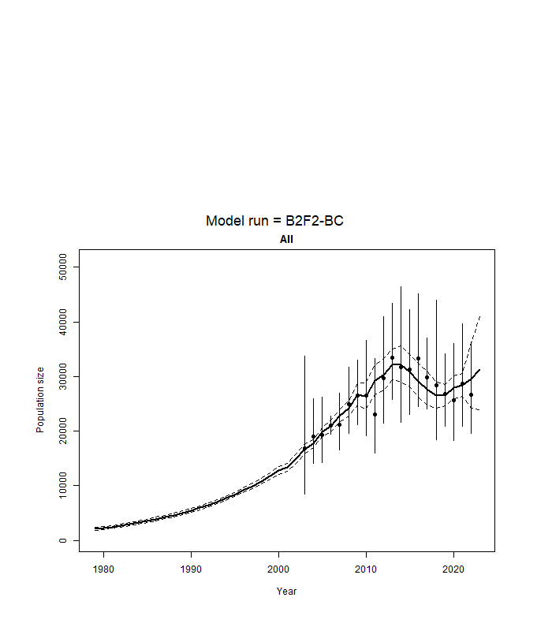
Fig. 1. Observed (solid dots) estimates of absolute abundance for the entire North Pacific with their 95% confidence intervals (vertical bars), and the model predictions (solid line) with their asymptotic 95% confidence intervals (dashed lines) from the base-case version of the model for the B2-F2 stock structure hypothesis.

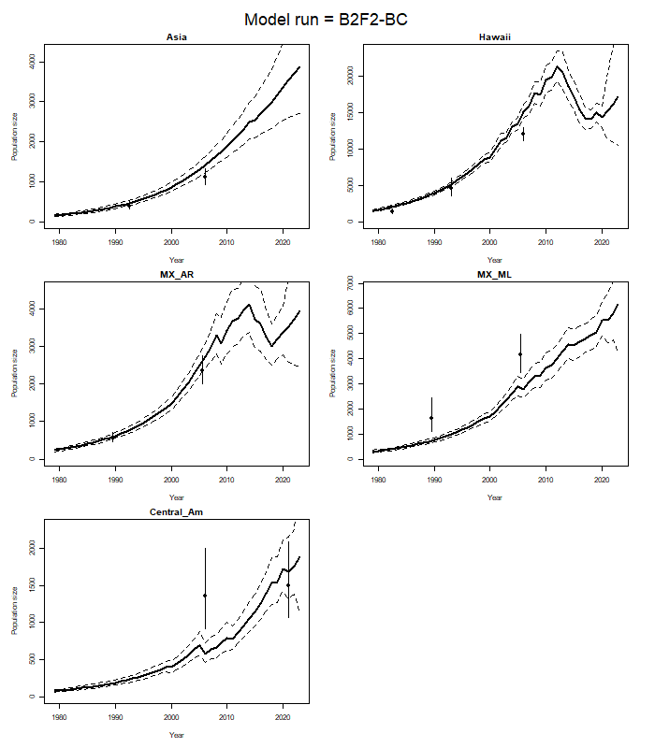
Fig. 2. Observed (solid dots) estimates of absolute abundance by breeding stock with their 95% confidence intervals (vertical bars), and the model predictions (solid line) with their asymptotic 95% confidence intervals (dashed lines) from the base-case version of the model for the B2-F2 stock structure hypothesis.

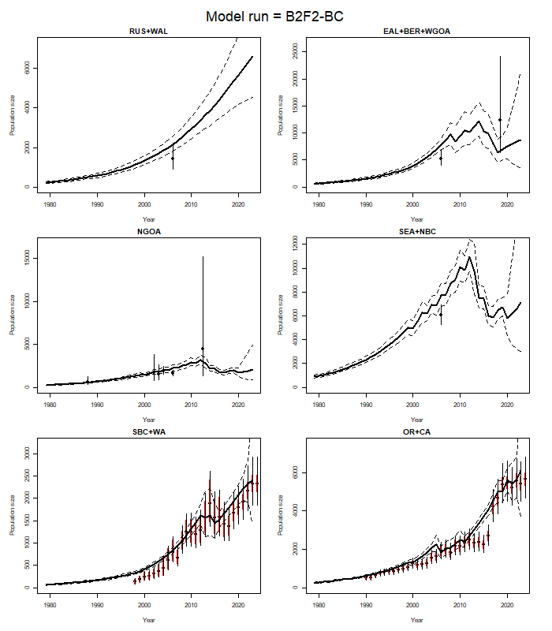
Fig. 3. Observed (solid dots) estimates of absolute abundance by feeding ground with their 95% confidence intervals (vertical bars; red sampling CVs only, black with additional variance added), and the model predictions (solid line) with their asymptotic 95% confidence intervals (dashed lines) from the base-case version of the model for the B2-F2 stock structure hypothesis.

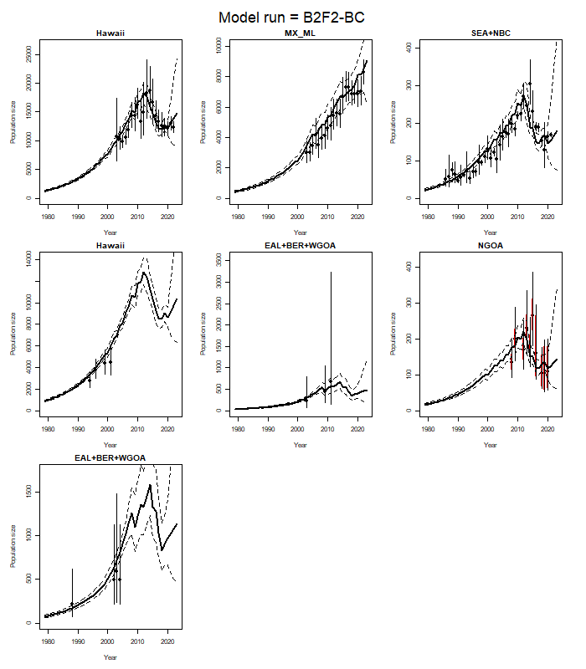
Fig. 4. The indices of relative abundance (solid dots) with their 95% confidence intervals (vertical bars; red sampling CVs only, black with additional variance added), and the model predictions (solid line) with their asymptotic 95% confidence intervals (dashed lines) from the base-case version of the model for the B2-F2 stock structure hypothesis.

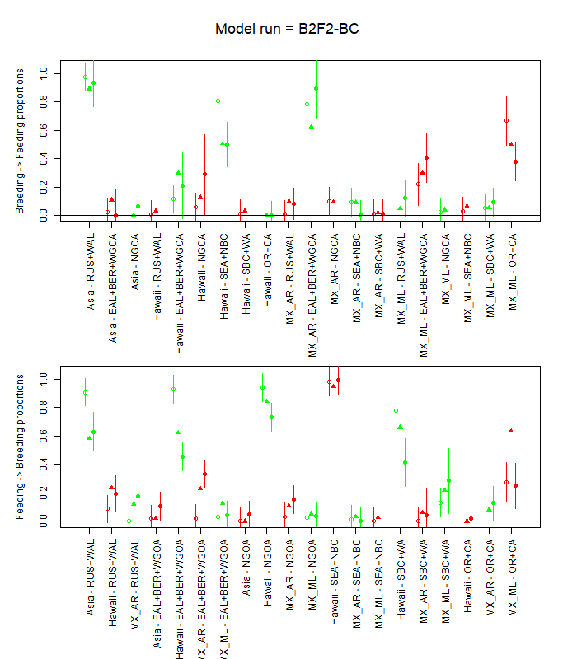
Fig. 5. Observed mixing proportions and their 95% confidence intervals (open circles mark-recapture estimates; closed circles genetics data) and the model predictions (triangles) from the base-case version of the model for the B2-F2 stock structure hypothesis. Results are shown in the upper panel for the split of each breeding stock to the feeding grounds and in the lower the panel the split of each breeding stock to the feeding grounds.

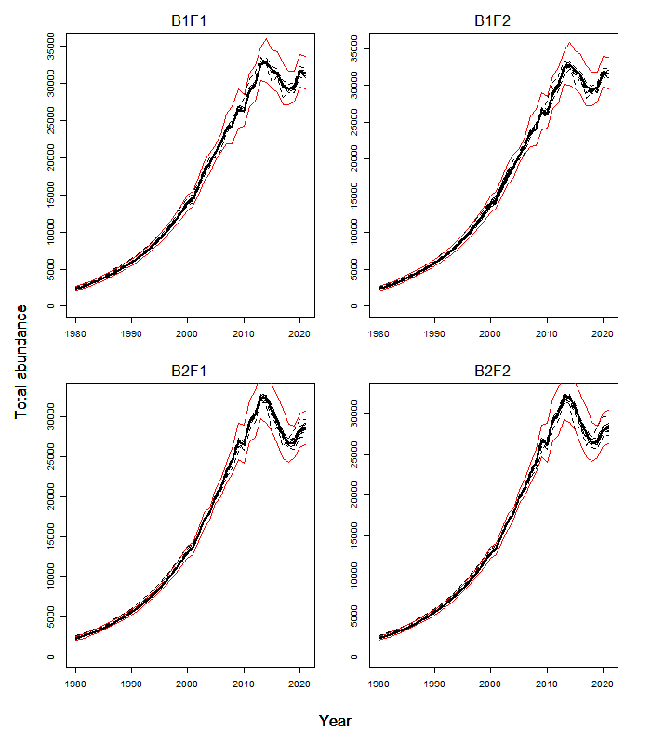
Fig. 6. Sensitivity of the time-trajectories of total abundance to varying the factors in Table D.1 of Appendix X. The solid line is the base-case model and the red lines indicate 95% asymptotic confidence intervals for the base-case model.

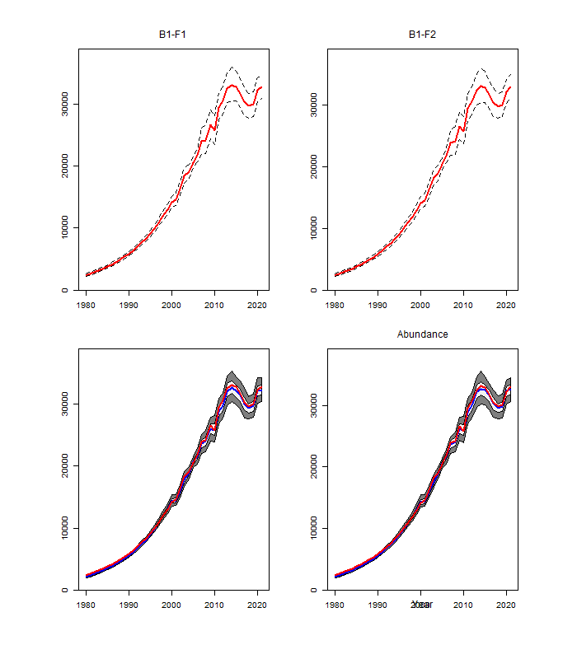Fig, 7. Model estimates of absolute abundance for the entire North Pacific with their 90% confidence intervals. Results are shown in the upper panel based on the asymptotic approximation and in the lower panel based on the bootstrap procedure. The light shaded area in the lower panel covers 50% of the distribution. No ready yet (wait until 2025
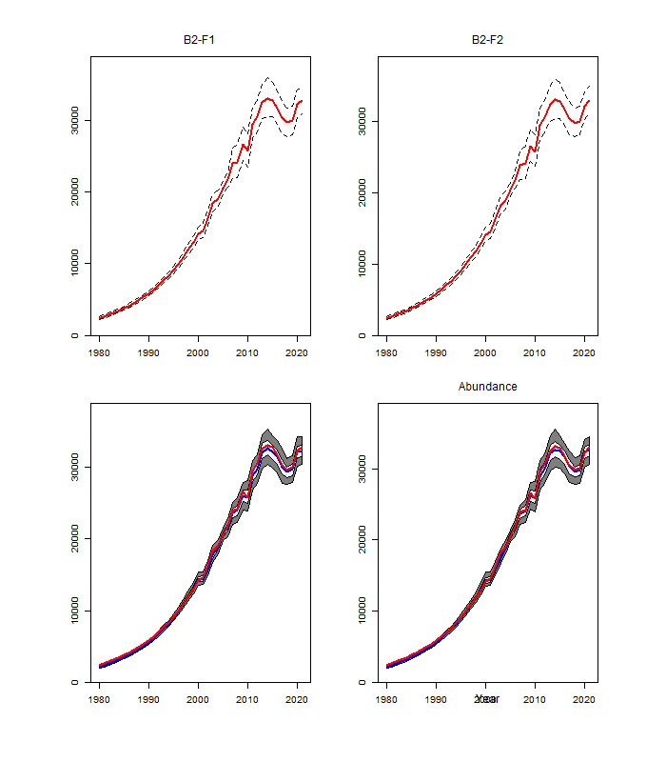
(Figure 7 Continued)

This is the key output compared among sensitivity tests.

